User Manual

(version 29-09-2019)

Page

How to become a Vendor/Seller 2

How to create your online Show-Room in 10 minutes 2

List of the Subcategories/Categories 48

**Orders**

View Orders (4.1) 34 TO SEE THE RESERVATIONS

Sales Report (4.2) 37

Shipments (4.3) 38

**Products**

Categories (1.1) 4

Products (1.2) 4 TO ADD YOUR PRODUCTS

Features (1.3) 19

Filters (1.4) 20

Options (1.5) 22

Pre-Order (1.6) 23 TO SETUP THE RESERVATIONS/ORDERS

Etsy Synchronization (1.7) DRAFT 23 TO SYNCHONISE WITH YOUR ETSY STORE

**Customers**

Vendor’s administration (7.1) 47

Customers (7.2) 47 TO SEE YOUR CUSTOMERS

Message Center (7.3) 47

**Website**

Blog (5.1) 42 TO CREATE YOUR BLOG

Pages (5.2) 45

**Vendors**

Vendors (3.1) 31 TO SEE YOUR PROFILE

Accounting (3.2) 31

Seller Vacation (3.3) 32 TO SHOW WHEN YOUR STORE IS CLOSED

**Messages**

Conversations (2.1) 29 TO COMMUNICATE WITH CUSTOMERS

-----------------------------------------------------------------

**Administration**

Shipping & Taxes (6.1) 46

Stores & Pickup Points (6.2) 46 TO SHOW YOUR STORE ON GOOGLE MAP

Currencies (6.3) 47

Logs (6.4) 47

Files (6.5) 47

Import Data (6.6) 47

Export Data (6.7) 47

**Design**

Themes (8.1) 48

Layout (8.2) 48

Need help? eBay, Amazon? 48

# How to become a Vendor/Seller

1- Register (under **My Account**)

* Enter your email address and a new password

2- Open your Show-Room

* Click on **Open your Show-Room**
* For the plan, click on **CHOOSE**

3- Apply

* Enter the name of your store and your information (address etc)
* Click on **SUBMIT**

Once we approve your registration, you will receive a confirmation email and you can start creating your Show-Room.

4- Go to [www.**departax/vendors.php**](http://www.departax/vendors.php)

* Enter your email address and password

# How to create your online Show-Room in 10 minutes

There are many options in our software but you may not need all of them.

Here is our guide to open your online Show-Room in just 10 minutes, using just the most important options.

Always select the ENGLISH language and the EUR currency

Our website is for the time being active only in English and in EUR

**1st step: Open your Show-Room**

REGISTER (under My Account)

Click on “Open you Show-Room”

For the plan, click on CHOOSE

* Enter your Store name and the (Country): ACME (Belgium)
* Enter a description of your activity with, at the end, your internet address (these will appear on your store page)
* Enter your first and last name
* Enter your email address, phone and address (all these in English)
* Click on SUBMIT

When we confirm your registration, you will receive an email and can then start creating your online Show-Room

**2nd step: Add your products**

Go to [www.departax.com/vendor.php](http://www.departax.com/vendor.php)

Enter your email address and password

Click on + Add Product

* Enter the name of the product and (the price and the local currency if it is not Euros): Chanel No.5 (USD 55)
* Category: select the **subcategory** from our list, see the list of subcategories at the end of this User Guide, and add also, as a second subcategory, the City name of your store (in English!). This will help customers find your store in the right categories on the Menu.
* Contact us if you need a new subcategory/category or a new City name
* Enter the **EUR price** of your product. This is the price including all the local taxes
* Click on SELECT images to upload the images of your product
* **Change In Stock to 0** (this will allow customers to order your products)
* Search: enter the name and the key search words of your product: Chanel No.5 perfume

Click on CREATE, click on the box ‘**Add-ons**’, go to **Preorder**:

* Enable PreOrder: select “**YES**”
* PreOrder Type: select “**Partial Price**”
* PreOrder Ending Date: select the date **31/12/2029**
* Maximum PreOrder Quantity: select “**1**”
* Per User Product: select “**1**”
* PreOrder Product Price: enter the % amount of your sale price in order to reach a PreOrder price of EUR 3

For example, your sale price is EUR 30, then you must enter 10% in this field, in order to reach a PreOrder price of EUR 3. The PreOrder price (EUR 3) is the price the departax.com user will pay us in order to reserve your product.

* Reviews: select “Communication and Rating” (your customer can leave a review or a rating on your product)

**3rd step: Show your store on the Map**

This will help your customers easily find your store, before or after travelling

Go to Administration -> Stores and pickup points

Click on + Add Store Location

* Enter the name of your store and the (location): ACME (City Centre)
* Enter the priority/position of your store, if you have multiple stores: 1, 2 etc
* Enter the address of the store
* Enter the phone number of your store
* Enter the working hours, opening days (in English!)
* Select the Country of your store
* Enter the City (in English!)
* Click on SELECT to find the position of your store on Google Map, and click on the exact position and then on SET
* Click on CREATE and then on SAVE

**How to Clone a product**

This will save you some time when adding products

Go to Products -> Products

Select the product you want to copy

Click on Actions, CLONE, and SAVE

Click on the new product and make the necessary corrections (Product name, Image, In Stock, Search words, etc)

Check if all the data is correct. You may need to go again to Add-on and correct the data there

**Show your logo**

Go to Vendors -> Logos

Click on Local and upload your logo on departax.com and also on invoices

**Terms & Conditions**

Enter your Terms and Conditions

**Show to your customers that your store is closed**

This will help your customers easily find your store, before or after travelling

Please refer to the User Guide

**Last step: Check again in all our website if your data is correct**

Go to List of Retailers

Go to Retailers by Category

Go to YOUR DESTINATION

Go to the category of your product

Go to Map

**Are you offering a VAT refund to tourists?**

Contact us to show the VAT Refund badge. This will attract more tourists

**Need help?**

Send us an email ([retailer@departax.com](mailto:retailer@departax.com))

# 1.1 Categories

You can see all the existing categories and the number of products you have in each category.

**The list of subcategories is at the end of this User Guide.**

Each category can include an unlimited number of child categories (**sub-categories**) which, in turn, can include their own child categories. Categories without a parent are called root categories.

Every product that you have in your catalog must be assigned to at least 1 **sub-category** (ex Wine).

**Don’t forget to assign your products to the city of your store** (ex YOUR DESTINATION **→** Europe **→** Belgium **→** Brussels).

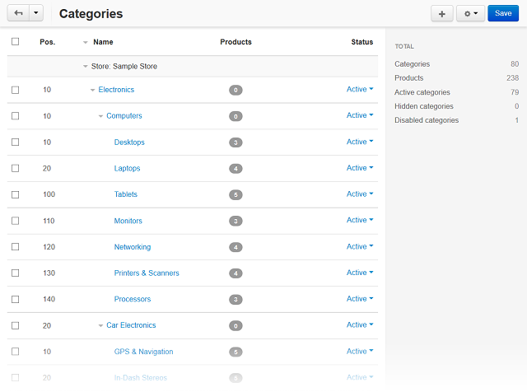

Contact us to create a new Subcategory (retailer@departax.com)

# 1.2 Products

Vendors can add and edit products using different methods.

* Adding One Product
* Adding Multiple Products
* Cloning a Product
* Cloning a List of Products
* Editing Multiple Products at Once
* Updating Prices and Stock for All Products
* Importing Products
* Adding a Digital Product

## Adding One Product

1. Go to **Products → Products**, then click the **+** button in the upper right part of the page.

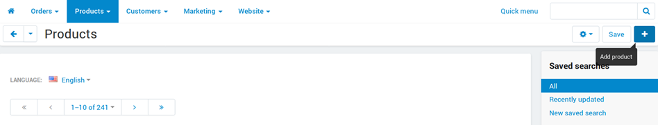

1. The product creation page will open. Configure the required properties of the product. You’ll be able to edit the product properties later at any time.

Some properties don’t appear during product creation and are available only when you edit a product.

1. Click the **Create** button.

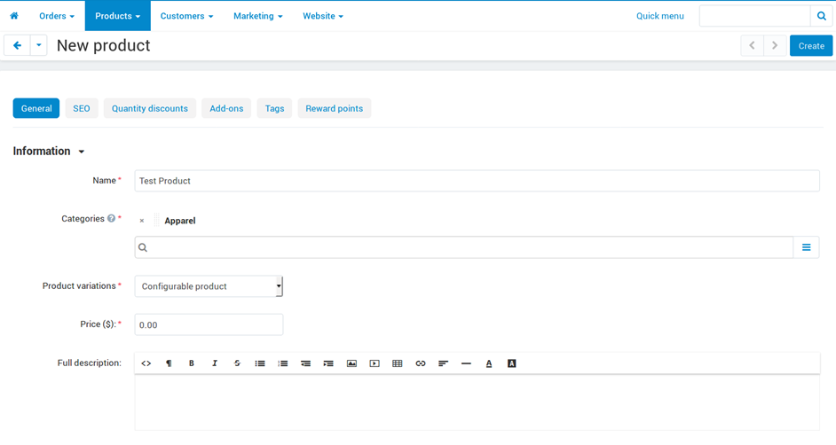

## Adding Multiple Products

1. Go to **Products → Products**.
2. Click the gear button in the upper right part of the page and choose **Bulk product addition**.

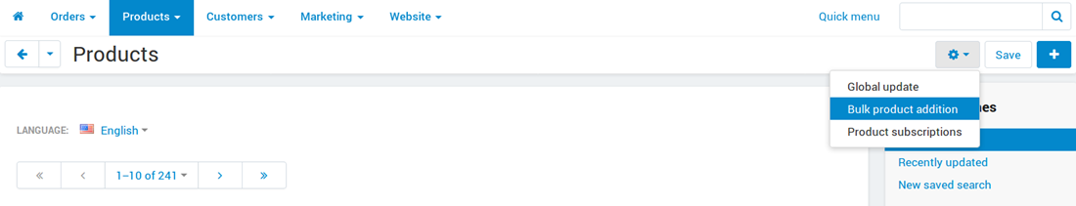

1. Add products and fill in the empty fields.

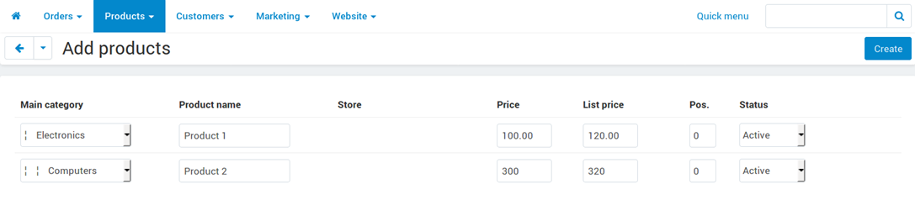

1. Click **Create**.

## Cloning a Product

If you plan to have several products with identical properties, you don’t need to create each of them manually. Instead of specifying the product properties each time that you add a new product, you can:

1. Set up one sample product with the common properties.
2. Clone the sample product.
3. Change the names and individual properties of the clone products.

## Cloning a List of Products

1. Go to **Products → Products**.
2. Select the products that you’d like to clone by clicking on them.
3. Choose **Clone selected** in the **Actions** menu.

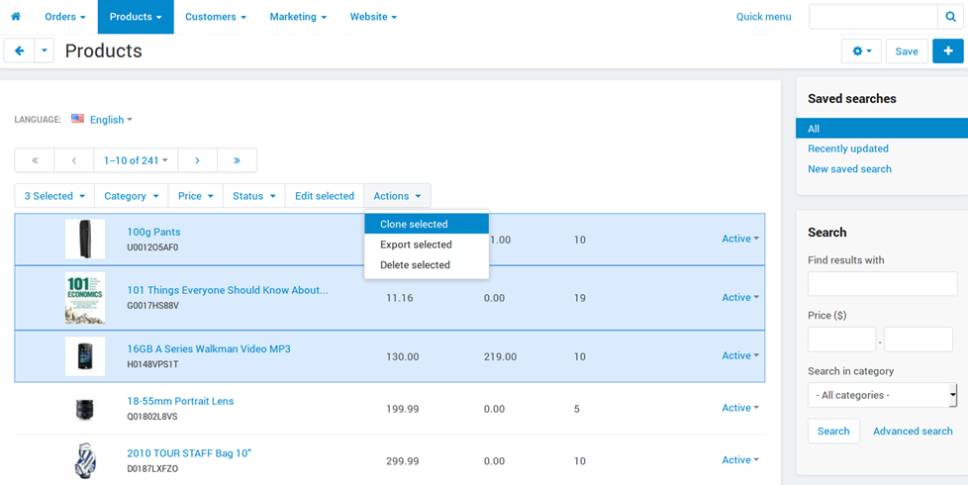

1. Clone products will be created with Disabled status.

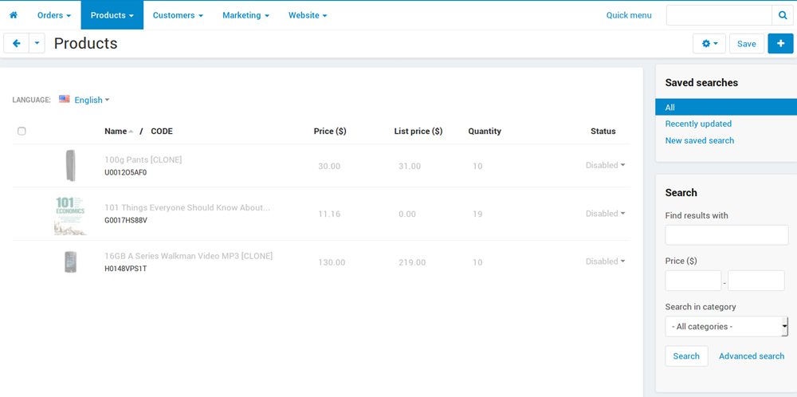

1. Edit the clone products and enable them by changing their statuses to Active.

### On the Product Editing Page

1. Go to **Products → Products**.
2. Click the name of the product you’d like to clone.
3. The product editing page will open. Click the gear button in the upper right part of the page and choose **Clone**.

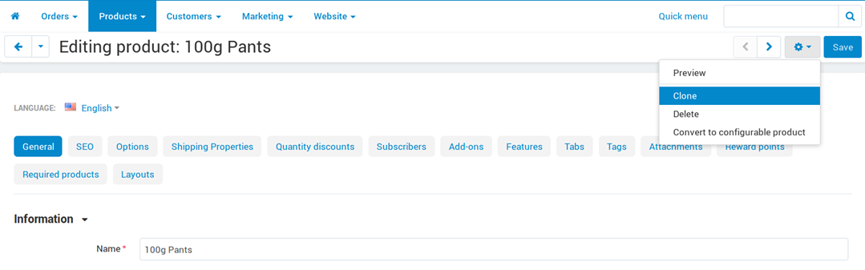

## Editing Multiple Products at Once

**You can edit the properties of a group of products.**

1. Go to **Products → Products** in the administration panel of your store.
2. Select the products that you’d like to edit by clicking on them.
3. Click **Edit selected** above the list of products.

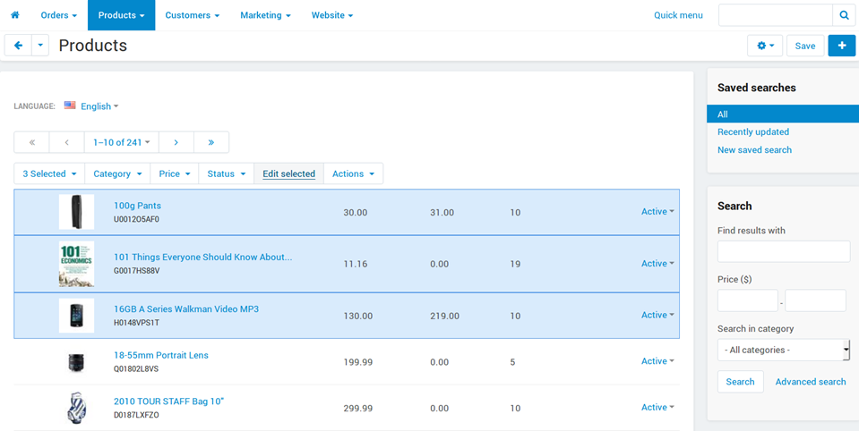

1. A pop-up window will open. Tick the checkboxes of the product properties you’d like to edit, then click **Modify selected**.

Avoid choosing too many properties at once, or else it will be inconvenient to edit them all.

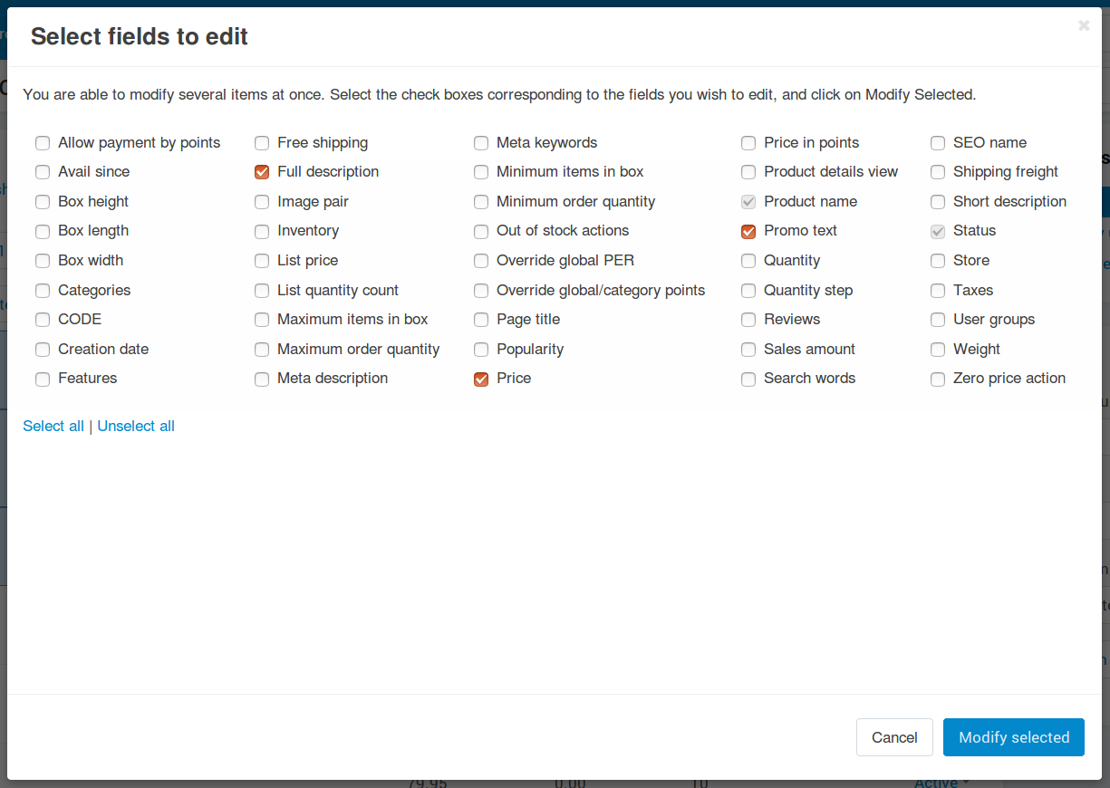

1. The selected products and their properties will appear on one page. Edit them, then click the **Save** button in the top right corner.

Use Apply values to all the selected products in the upper left part of the page to update the value of the property for all the selected products at once.

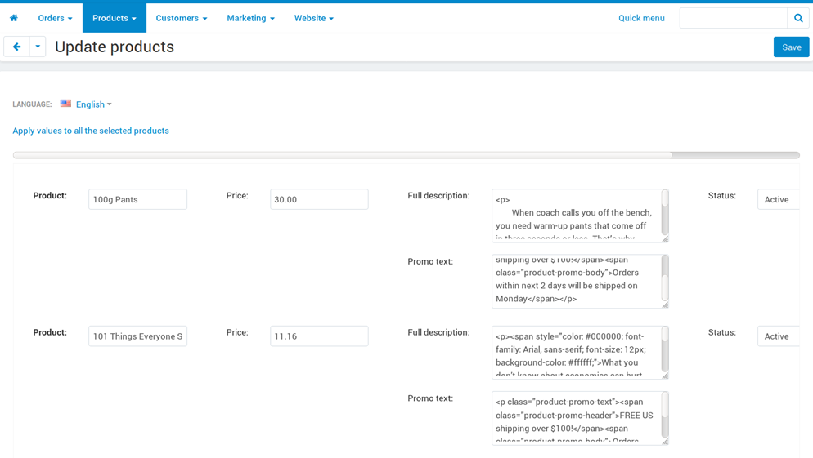

## Updating Prices and Stock for All Products

You can update some properties for all products at once.

For example, you can increase the prices of all products by 10% or you can increase the list price to display discount labels on all products.

To update all products:

1. Go to **Products → Products**.
2. Click the gear button in the upper right part of the page and choose **Global update**.

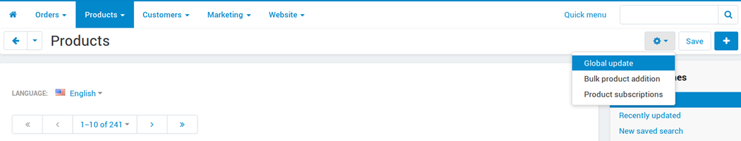

1. A new page will open. There you can update the following product properties:
   * Price
   * List price
   * In stock (the number of products in stock)
   * Price in points

By default, the update is performed for all products. But if you use the **Add product** button, then the properties will be updated only for the selected products.

1. Once you’ve chosen how to update product properties, click **Apply**.

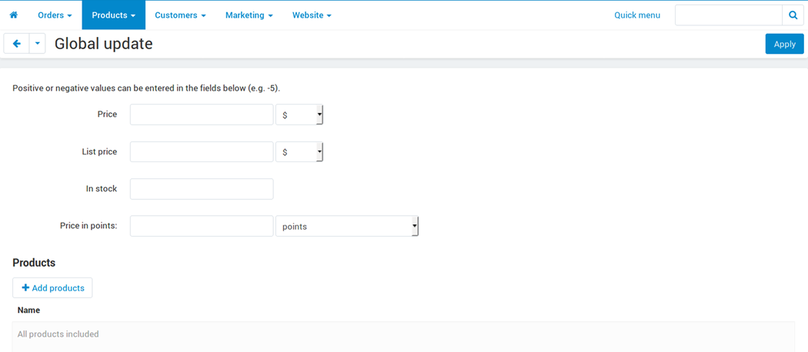

## Importing Products

You can import (upload) products from a CSV file. CSV is a popular spreadsheet format. A line in a CSV file is one line of the table.

CSV files can be edited in spreadsheet editors such as LibreOffice Calc, OpenOffice Calc, Microsoft Excel. We recommend using LibreOffice (a free office suite) to edit CSV files.

To demonstrate the full process, let’s export one of the products to a CSV file first.

1. Go to **Products → Products**.
2. Select the products you’d like to export by clicking on them.
3. Choose **Export selected** in the **Actions** menu above the product list.

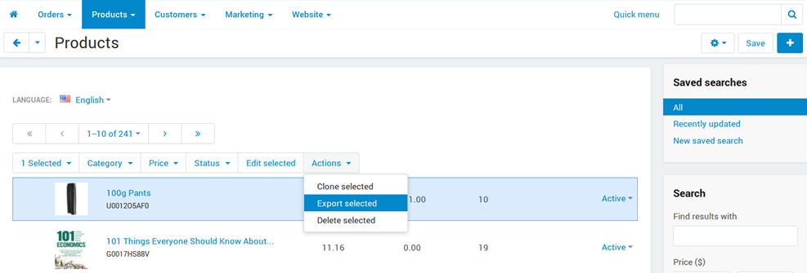

1. The **Export data** page will open.

There you will be able to chose the exported fields and change export properties. Each exported field is an equivalent of a product property. We recommend that you leave everything as is for the first time. After everything is set up, click **Export**.

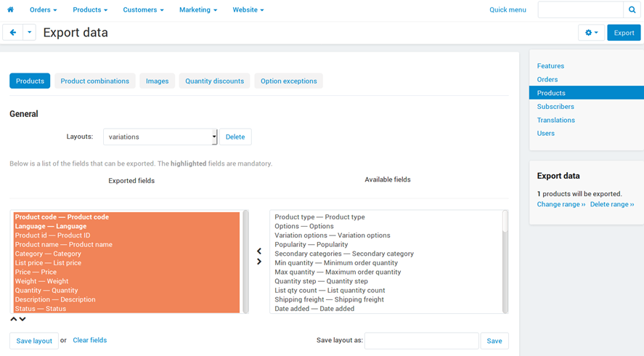

1. Open the exported file in the spreadsheet editor. The default delimiter for CSV is semicolon.

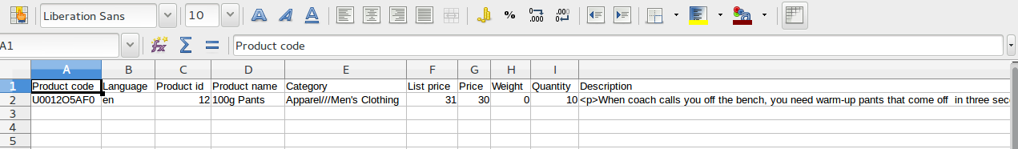

1. Each column of the table contains the specific type of the product data.

The product is identified by the Product code; it means that:

* + All products must have unique product codes.
  + If a product code already exists in a database, the product with this code will be updated or replaced.
  + If the product doesn’t exist in a database, a new product will be created.

When you import a product, some fields are required:

* + Product code
  + Language
  + Store—the storefront to which the product belongs.
  + Product name—the name of the product
  + Category—the category to which the product belongs

If a category doesn’t exist in the database, it will be created. Use category delimiters to create a tree-like category structure and add a product to a specific subcategory.

Other fields are optional. This time we recommend exporting only these required fields.

1. Use the sample product as an example and add new products to the table. Each line is a new product.

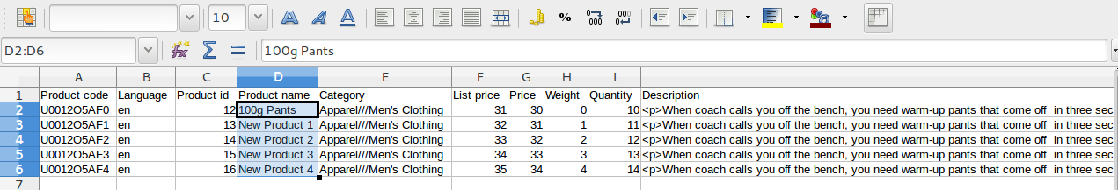

1. Save the file in the CSV format, and you’ll be able to import it.

## Adding a Digital Product

You can also sell digital products.

1. Add a product (see above).
2. Open the **Files to sell** tab on the product editing page.

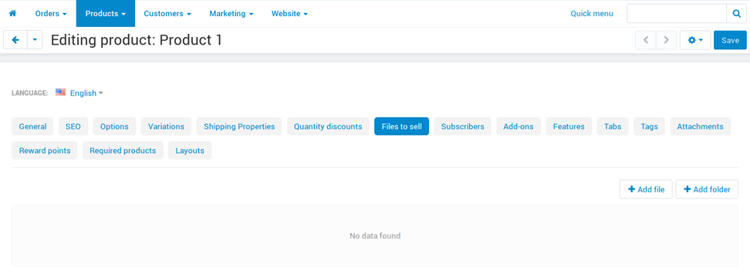

1. Add the files that you want to sell. Files can be grouped by folders.

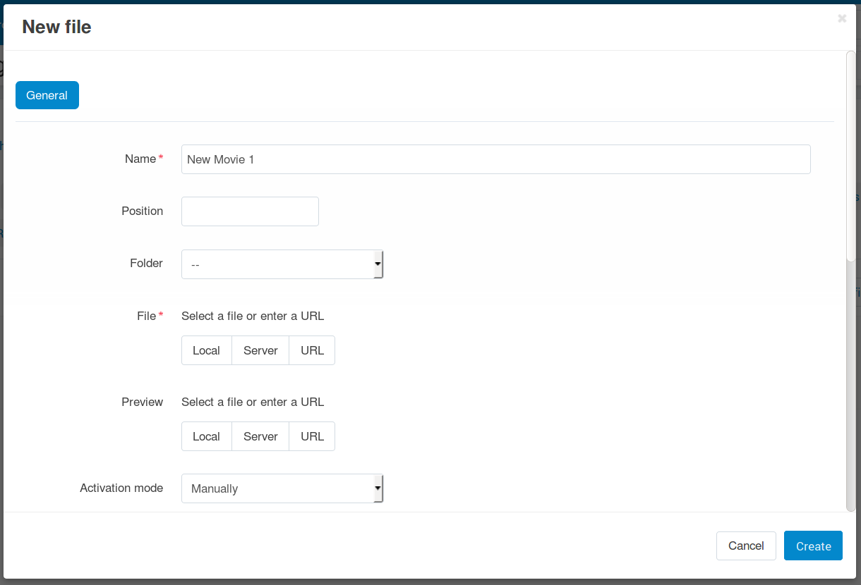

1. The additional properties are available for digital products on the **General** tab in the **Extra** section:
   * Downloadable: this checkbox is ticked automatically after the file is added to the product.
   * Enable shipping for downloadable products: if this checkbox is ticked, shipping costs will be calculated for this downloadable product just like for normal products.
   * Time-unlimited download: if this checkbox is ticked, the product download period never expires.

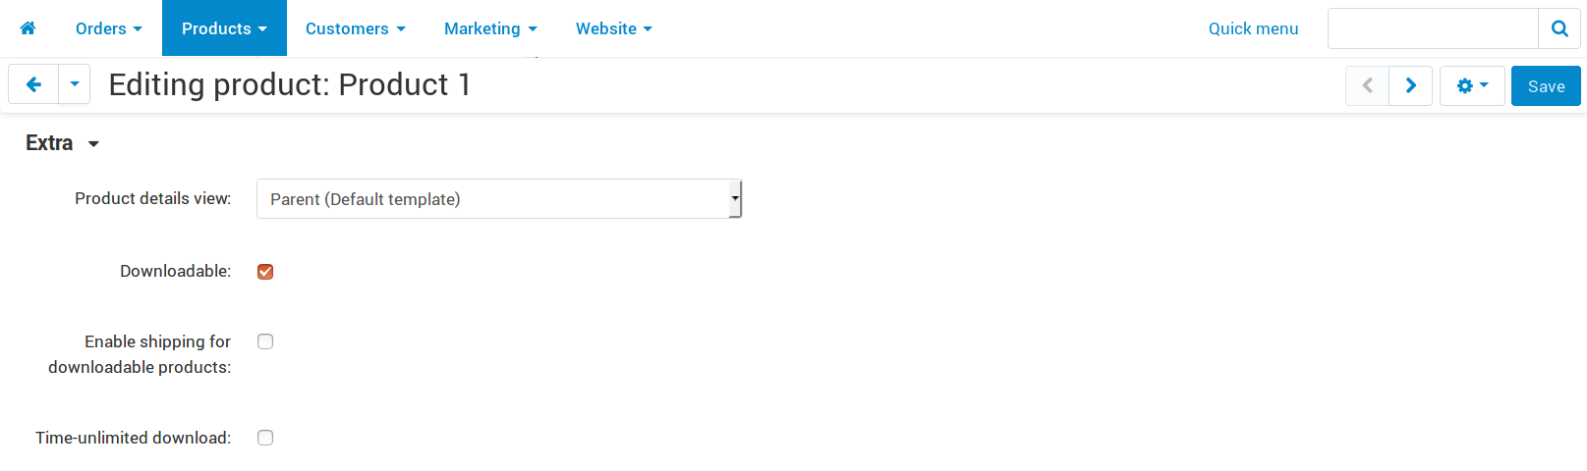

The digital product has been created. Create a test order and check the result.

If you uploaded a file for the downloadable product, there will be the **Files** tab on the product page on the storefront.

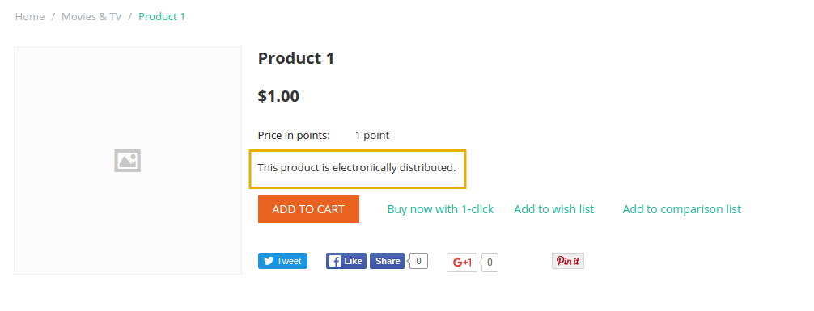

**Once a digital product is purchased:**

1. An email with the download link is sent to the customer.
2. The download link will become available on the order details page of the customer’s account.

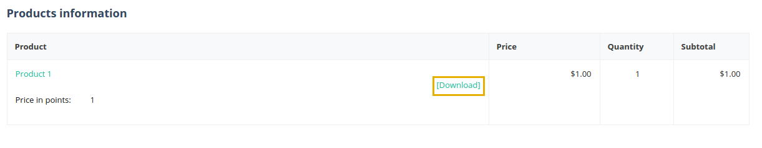

1. All the purchased digital products will be available to the customer on the **Downloads** page of the customer’s account.

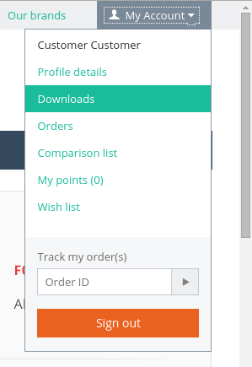

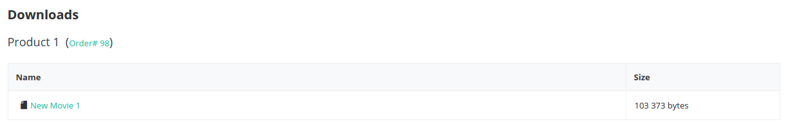

In the administration panel, orders with downloadable products will appear on a new tab called **Downloads**. Vendors can approve the download, prolong the download availability period, and check the number of downloads left.

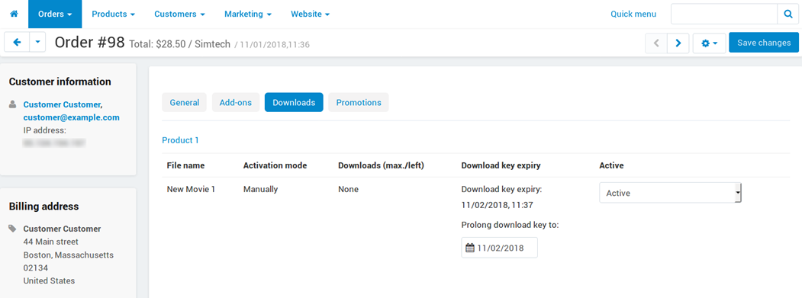

# Product Variations (see our example on www.departax.com/fashion-women/clothing/t-shirt/)

Variations are similar products that differ from each other only in one or a few [features](https://docs.cs-cart.com/latest/user_guide/manage_products/features/index.html), for example: “**green M-sized T-shirt**” and “**red S-sized T-shirt**”. This kind of product requires 3 things:

1. Let customers choose the feature values on the product page.
2. Show some of the variations (for example, different colors) as separate catalog items. That way customers will see the color they need on the product list.
3. Hide some of the variations (for example, sizes) from the product list. That way customers wouldn’t be confused by multiple T-shirts of different sizes with the same image.

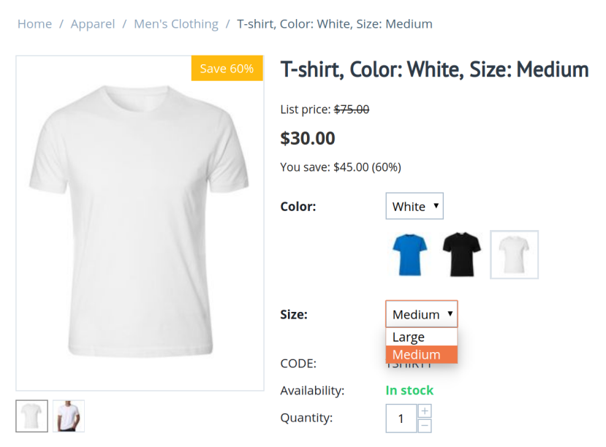

## Terminology

**Variation group**—a few similar products that differ from each other only in one or several features.

**Variation**—a product that belongs to a variation group. A product can belong only to one group at the same time, but it’s easy to change the product’s group. If a variation is removed from the group, it becomes a standard product.

**Catalog item** — a single spot on the product list. Until variations existed, “catalog item” meant the same thing as “product”. But now variations may or may not occupy a place on the product list, hence the new term.

Every variation is a product, but not every product is a variation. Use the **Advanced search** on the product list in the admin panel. For example, it can let you find only variations, or only catalog items.

A T-shirt comes in 3 colors, and each color has 5 sizes. That means 15 products. If we want to add switching between these products, we’ll put these products into a variation group that is based on the “Color” and “Size” features. Now we have 15 variations, and customers can switch between them on the product page.

Depending on how your features are configured, these 15 variations can be:

* 1 catalog item—the color and size selection is available only on the product page.
* 3 catalog items—T-shirts of different colors appear on the storefront as separate products, but sizes can be selected only on the product page.
* 5 catalog items—if someone decides to show sizes on the product list and leave the color selection on the product page. It doesn’t suit T-shirts, but may be appropriate for other products.
* 15 catalog items—when colors and sizes appear on the list as separate products; every variation has its own catalog item.

This scheme works even when the number of features is more than two. You can edit the features at any time, but the number of catalog items will change only if you disband and recreate the variation group. More on that below.

## Working with Variations

### Creating a Variation Group

1. Go to the editing page of a [product feature](https://docs.cs-cart.com/latest/user_guide/manage_products/features/index.html) (either a new one, or existing one) and choose one of the two **Purposes** that allow creating variations.

The selected Purpose determines if variations with different values of this features will become separate catalog items. Every purpose has a description; it should help you find the purpose that is right for you.

If variations differ by more features than one, then create multiple features, not necessarily with the same **Purpose**. Then the software will automatically determine, which variations should get their own catalog items, and which should only be selectable on the product page.

1. Go to the editing page of any [product](https://docs.cs-cart.com/latest/user_guide/manage_products/products/index.html) that you want to turn into a variation. Make sure that the product has a value for all the features that distinguish it from other similar products.
2. Switch to the **Variations** tab.

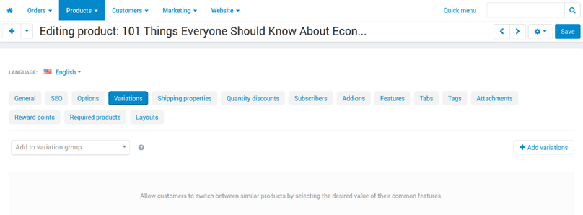

There are 2 ways to let customers switch from this product’s page to other similar products:

* + **Create a variation group.**

To do it, use the **Add variations** button. You’ll be able to add any products that have the values for the distinguishing features. You’ll also be able to create new products automatically, based on features.

* + **Add this product to an existing group as a variation.**

Start entering the variation group code into the field on the left. The software will automatically offer appropriate groups. If you know there is a group, but the software doesn’t offer it, then please make sure that the product has values for all the features that the group is based on.

## Management and Removal

Once a variation group is created, all products from the group will appear on the **Variations** tab of any product in the group. On this tab you can:

* See which variations have their own catalog item, and which don’t. A variation that doesn’t appear on the product list has a smaller icon.
* Choose which of the variations to display by default as the catalog item.

Other variations will borrow many of their properties from the variation that is selected as default.

* Remove a variation from the group; this will turn the variation into an independent product.
* Delete the variation.
* Change the group code — you can use it later to add other products to this group as variation. A group code can contain only digits, Latin characters, and the following signs: - and _.
* Add more variations to the group.
* Switch to the product list to edit variations there—that way you’ll be able to edit and remove variations in bulk.
* Disband the group—turn all its variations into independent products and remove the ability to switch between them on the product page.

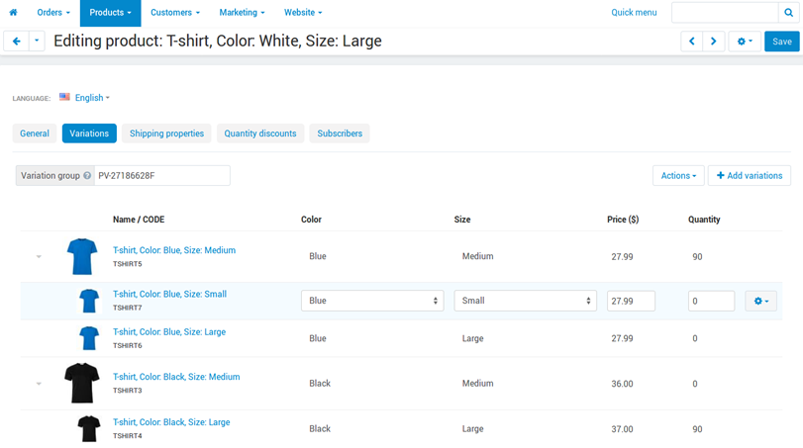

## How To Attach Files to Products

Attaching a file to a product is useful when you need to make some information freely available for all your existing and potential customers. For example, if you sell programs, you can make a PDF manual available for anyone who visits the product page.

1. In the Administration panel, go to **Products → Products**.
2. Open the editing page of the necessary product by clicking on its name.
3. Switch to the **Attachments** tab and click the **Add attachment** button.
4. In the opened form, specify the name of the new attachment and upload a file in the **File** section.
5. Click the **Create** button.

A customer will be able to download this file in the **Attachments** tab on the product details page in the storefront.

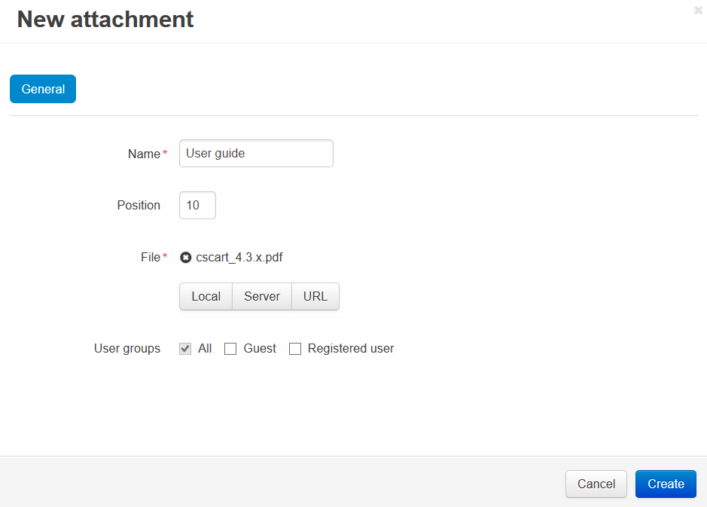

## How To Set up a Minimum Order Quantity for a Product

To set up a minimum order quantity for a product:

1. In the Administration panel, go to **Products → Products**.
2. Click on the name of the product you’d like to edit.
3. Enter the desired number in the **Minimum order quantity** input field under the **Pricing/Inventory**section.

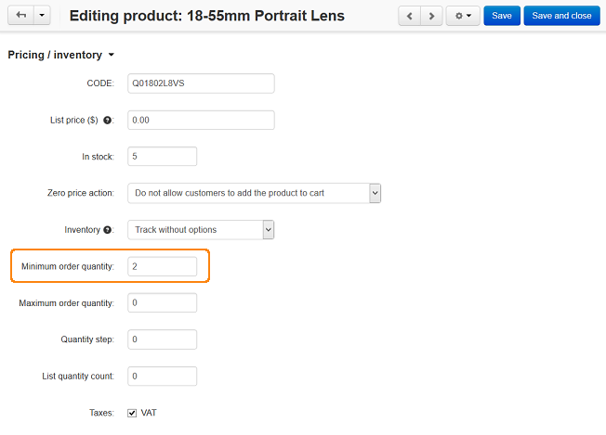

1. Click the **Save** button.

After that a customer will not be able to buy fewer items of this product than the number set up in the Minimum order quantity option.

# 1.3 Features

**Features** are additional product properties.

You can use them to add information that is specific to the products you sell.

For example, if you sell printed books, you can add a field for ISBN; if you sell music, you can add a field for the audio format, etc.

The **Products → Features** section contains a list of all product features that are available in your store.

Optionally, you can arrange features into groups and then edit the properties of the whole group instead of editing every single feature.

Use the menu on the right to switch between the lists of features and feature groups.

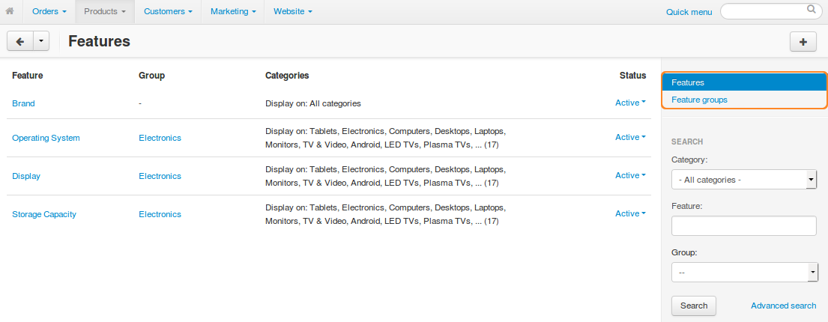

You can use features to filter products in the advanced search in the Products → Products section.

Contact us to ask to create a new feature.

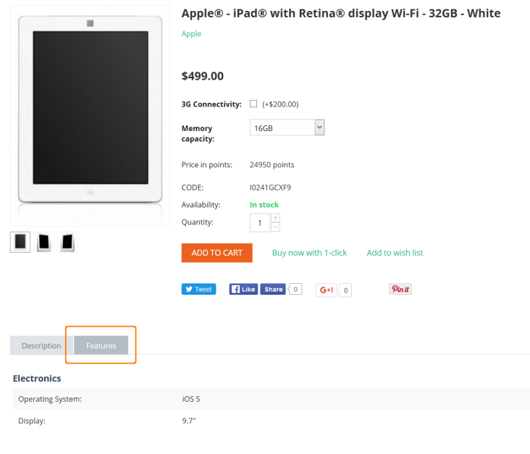

# 1.4 Filters

Product filters are displayed on the storefront and enable your customers to quickly find the products that have specific parameters like the price range, manufacturer, etc.

The parameters can be either the standard product fields or the extra fields defined in **Products → Features**.

A filter by feature will be disabled automatically, if you change the status of that feature to **Hidden** or **Disabled**.

Departax can make filters available in the entire store as well as in specific categories only.

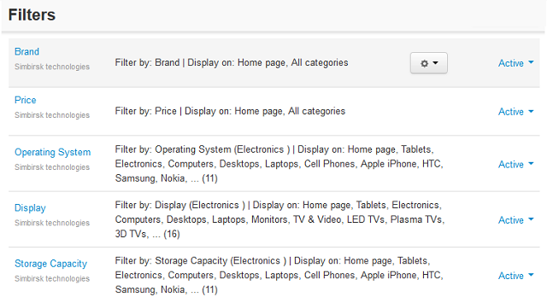

## How To Add a Product Filter

## Adding a Filter

1. In the Administration panel, go to **Products → Filters**.
2. Click the **+** button on the right and specify filter properties in the **New filter** window that will open.

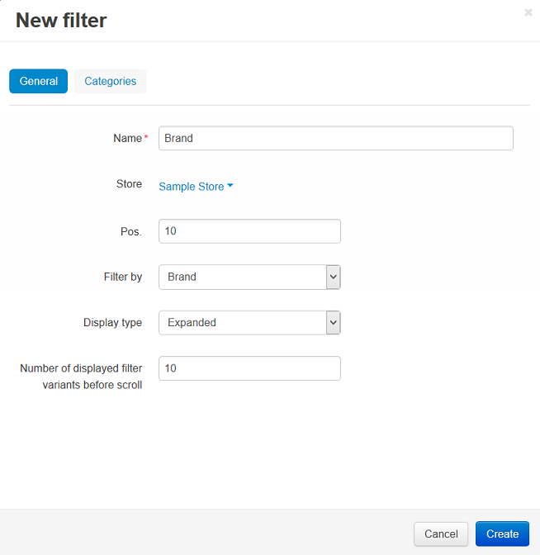

1. Switch to the **Categories** tab.
2. Click the **Add categories** button and add categories where this filter will be displayed.

If a category is selected, the filter will be displayed only on the page of that category.

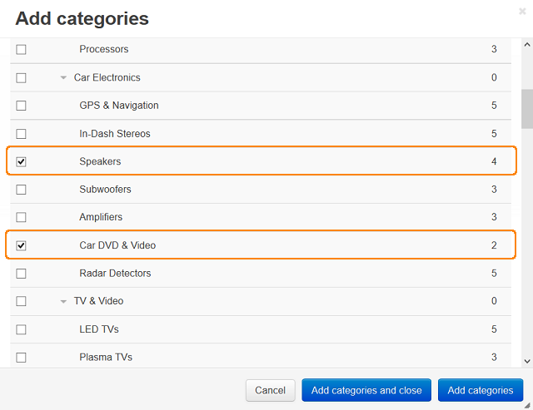

1. Click the **Create** button.

## Adding a Block for Filters

Filters appear on the storefront in a **Product filters** or **Product filters for homepage** block. To create this block:

1. Go to **Design → Layouts**.
2. Click the **+** button in the necessary location and click **Add block**.
3. Switch to the **Create New Block** tab and click the **Product filters** or **Product filters for homepage**.
4. Enter the block name (for example, My filters) on the **General** tab.
5. Choose the desired **Template**:
   * **Original**—a box with all available product filters and a price slider.
   * **Selected filters**—a box with filters selected by a customer.
   * **Horizontal filters**—a box with all available product filters; the filtering criteria are selected in drop-down menus.
6. Switch to the **Content** tab and click the **Add filters** button.
7. Tick the checkboxes of the desired filters and click the **Add filters and close** button.

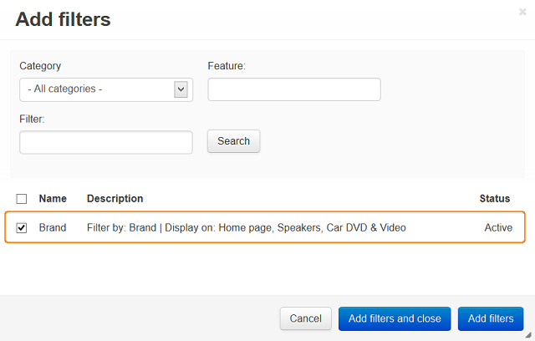

1. Click the **Create** button.

# 1.5 Options

The **Products → Options** page allows you to manage global product options and option variants in your store.

Global options work in the same manner as the product-specific options, but they can apply to multiple products.

* To add a new option, click the **+** button.
* To apply existing options to specific products, click the **Apply to products** button.
* To edit or delete an option, hover the mouse pointer over the option, click the **gear** button, and choose the action from the drop-down list.
* To make an option Active or Disabled, use the drop-down list to the right.

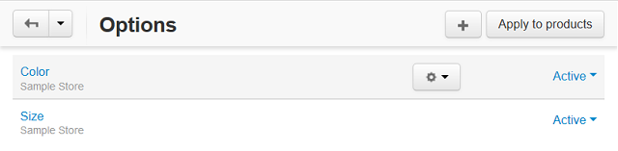

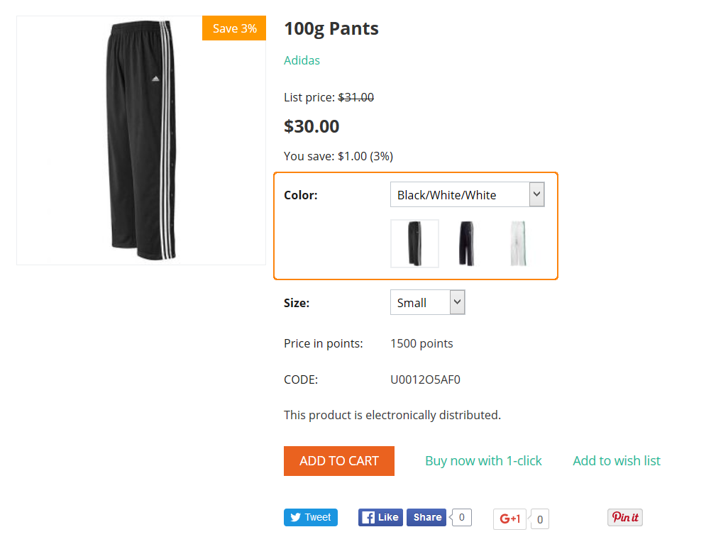

# 1.6 Pre-Order

We use Pre-Order to allow customers to make a product reservation for just EUR 3 and be sure to get their products on arrival to the stores.

Please refer to the steps at page 3.

# 1.7 Etsy Synchronization

If you are a seller on Etsy, you can also easily reach more potential buyers with Departax.

You can import your products from Etsy into Departax, or vice-versa.

Once the configuration has been done, the synchronization with your Etsy store will be automatic.

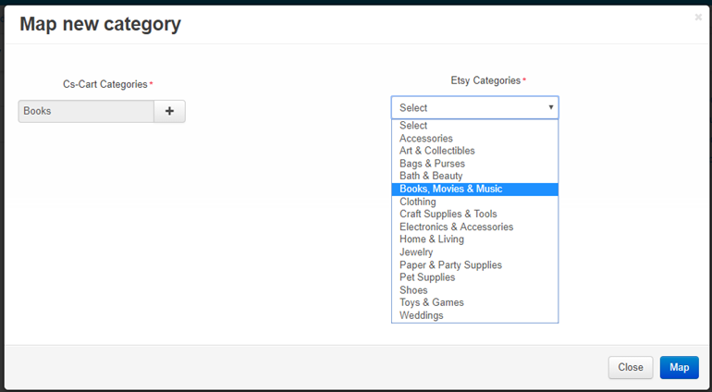

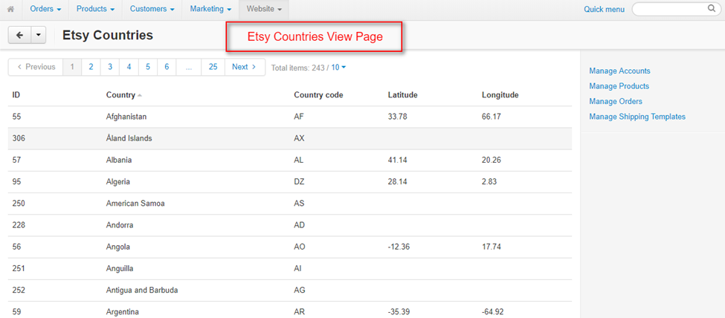

Go to Website -> Etsy Connector

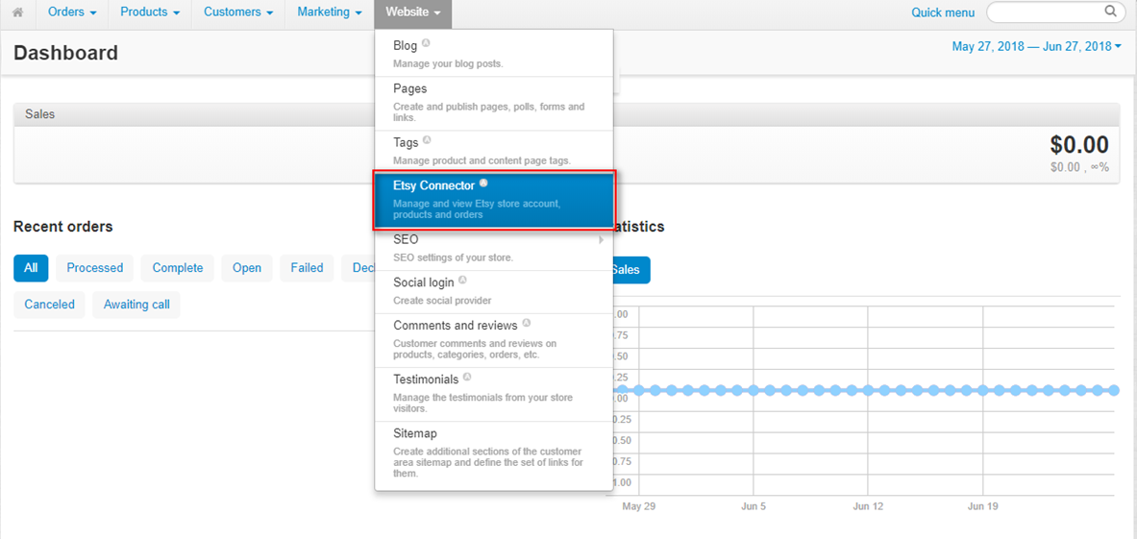

Click on + Add your Etsy store

Click on Edit Account

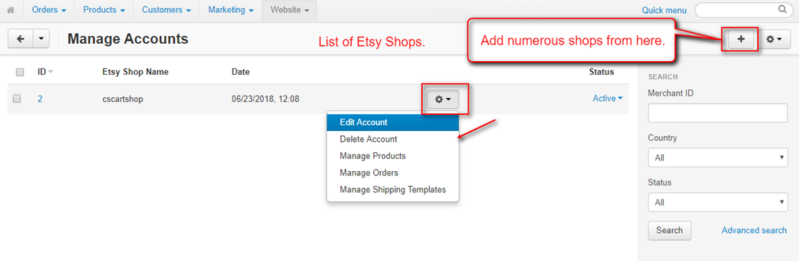

Under the box General:

* Enter your Etsy API key
* Enter your Etsy secret key
* Enter your Etsy shop name
* Click on Authenticate

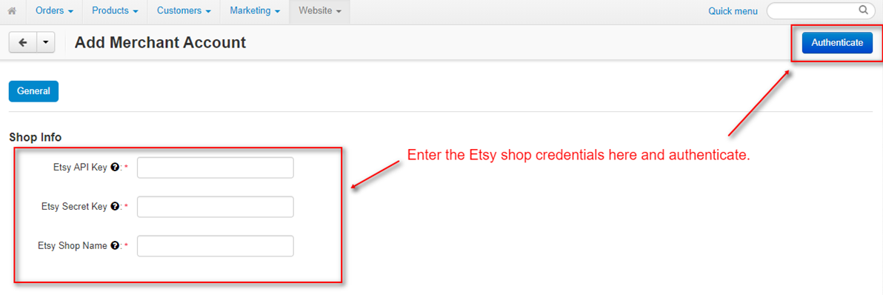

To do this, you will need to ask the API in Etsy:

Go to [www.etsy.com/developers/register](http://www.etsy.com/developers/register)

If you want more info, go to [www.etsy.com/developers/documentation](http://www.etsy.com/developers/documentation)

* Application Name: enter
* Describe your Application : enter
* Application Website : enter
* What type of application are you building? : select **Seller tools**
* Who will be the users of this application? : select **The general public**
* Is your application commercial? : select **No**
* Will your app do any of the following? : select **Upload or edit listings**

Under the box Product Settings, enter your default Etsy setup

For the moment, we don’t allow shipments from our platform. Contact us if necessary.

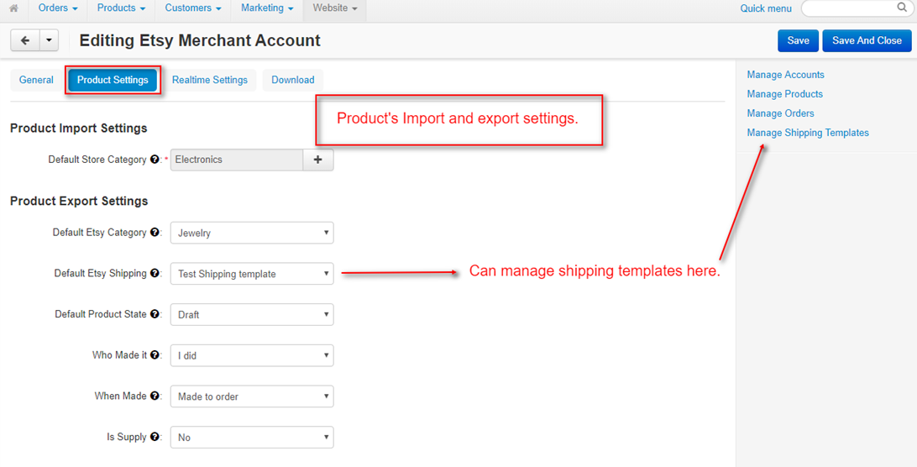

Under the box Realtime Settings, click if you wish to have n automatic synchonisation between your Etsy store and your D store.

Click on SAVE.

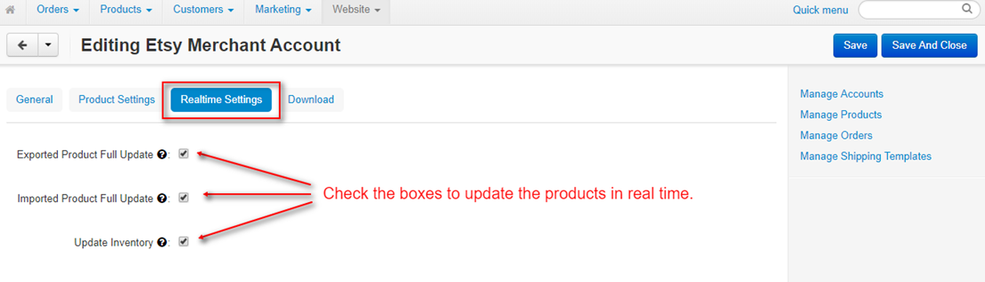

Under the box Download, you can map the Etsy categories to the D categories.

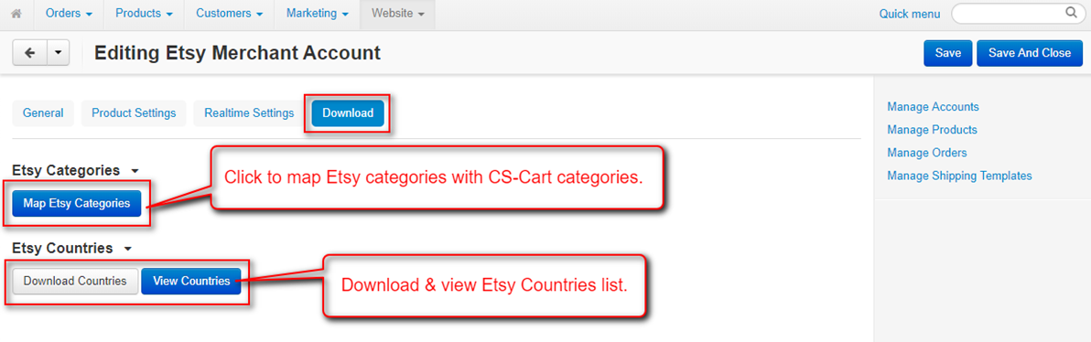

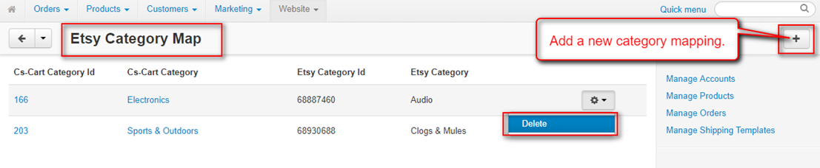

Go to Manage Products,

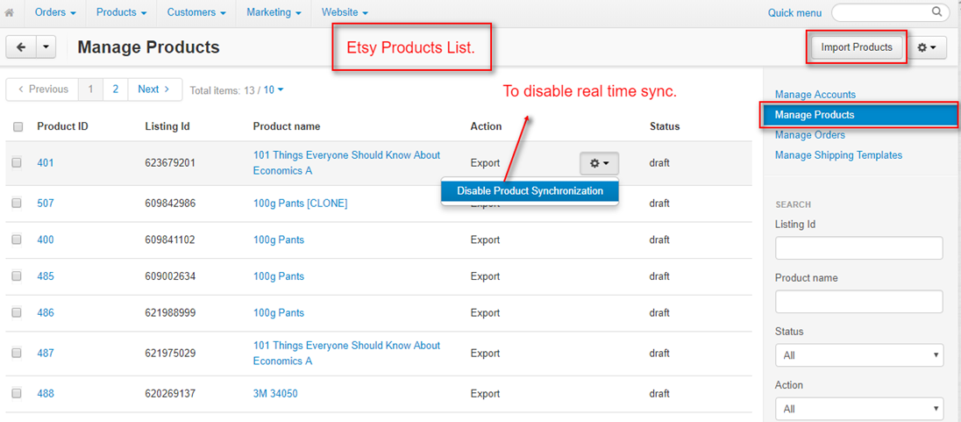

If you wish to import from Etsy, you can chose to do it

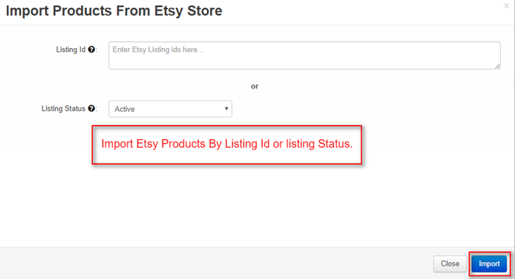

The following options Manage Orders or Manage Shipping are not useful in D.

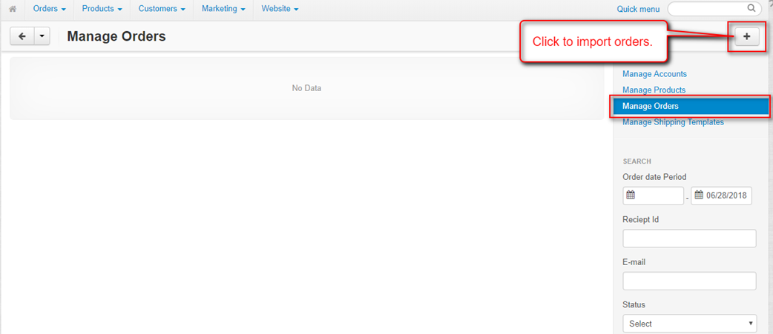

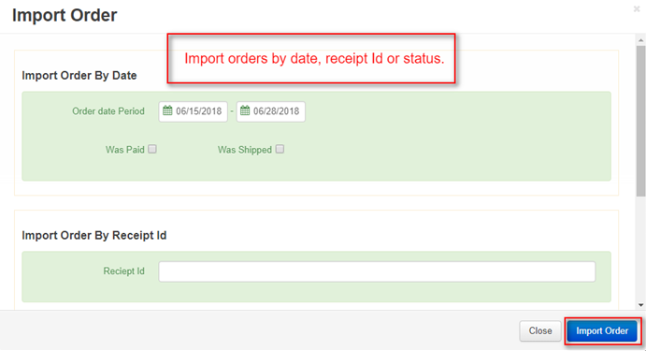

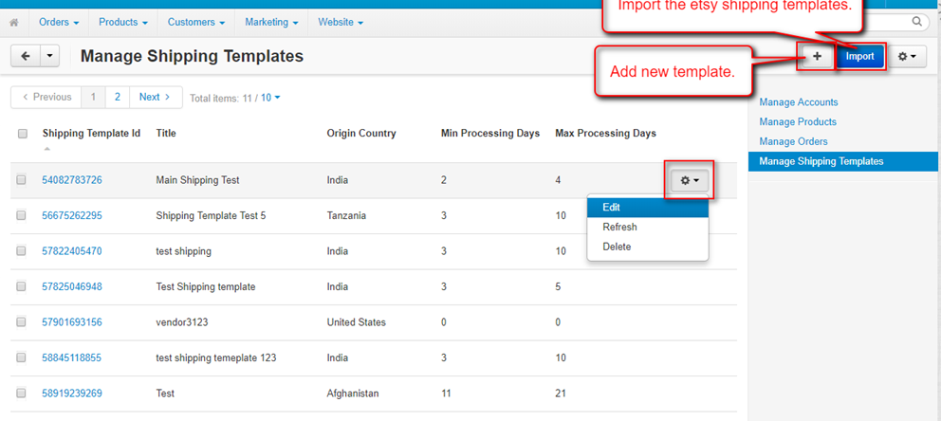

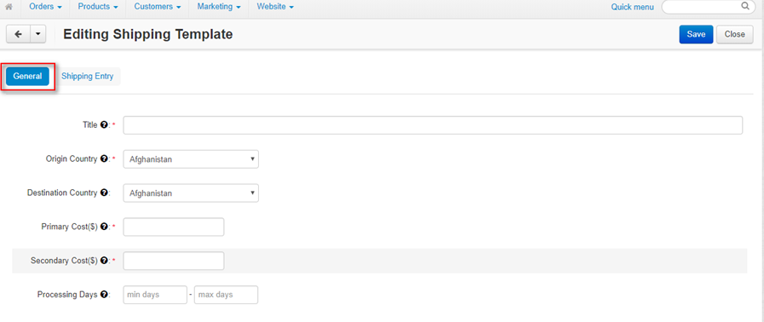

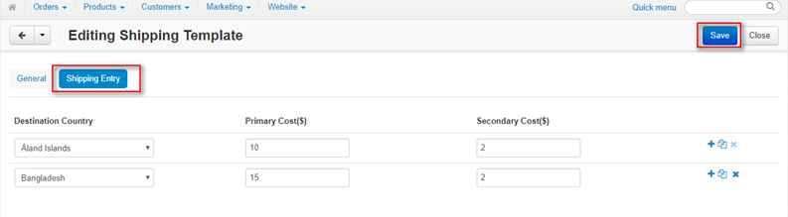

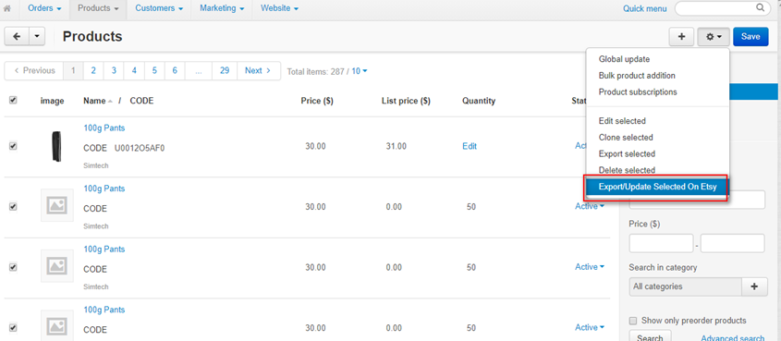

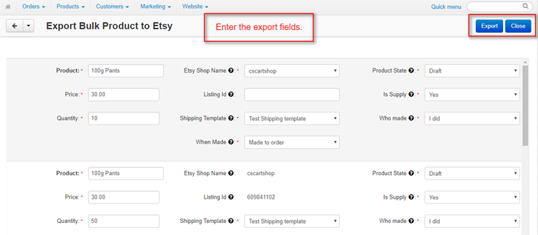

# 2.1 Conversations

You can exchange messages (and send files like pictures) with customers.

It can be very useful if the customer wants to ask questions about your products, prices, reservations and delivery.

You can write a message under Message, you can attach files (picture, photo, etc), and click on SEND.

# 

The customer starts a conversation by clicking on the **Contact Vendor** button.

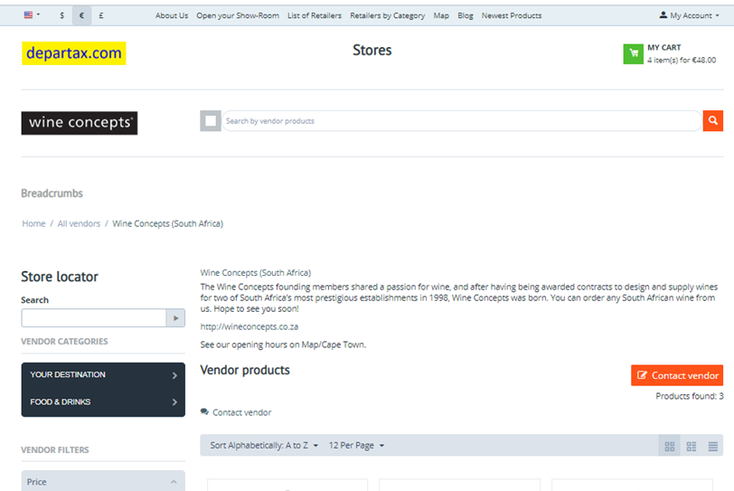

# 

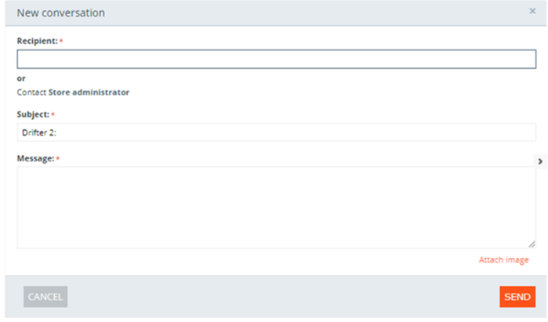

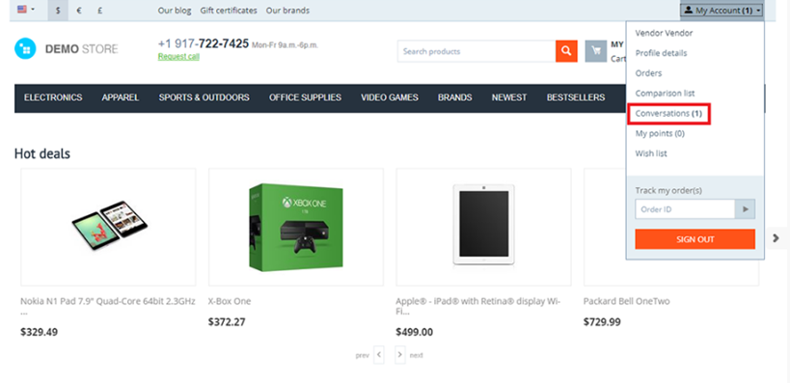

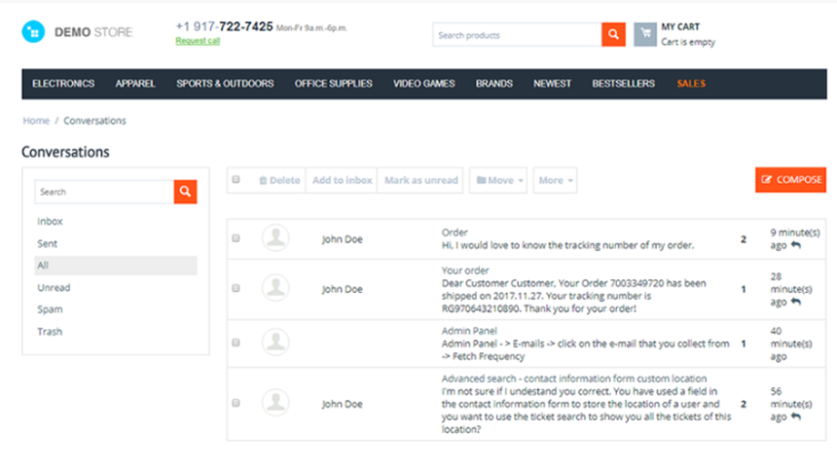

# 3.1 Vendors (= Retailers/Sellers = You)

You can change the profile of your store.

* Description: describe your store
* Logos: insert your own logo
* Terms & Conditions: enter your own terms & conditions
* Reviews: you can see the reviews of your customers and answer to them (click on “New Conversation”)

# 3.2 Accounting

This tool helps you keep track of your income and transactions.

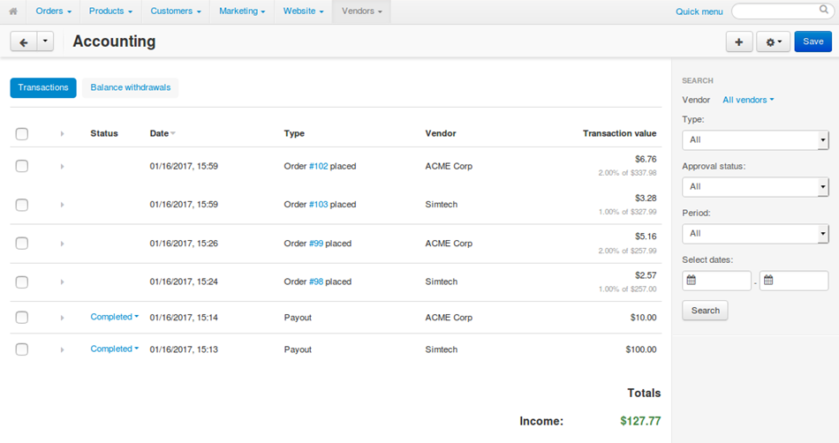

The table on the **Accounting** page consists of the following columns:

* **Status**—the status of the transaction; it applies only to payouts (not used for now) and withdrawals (not used for now). There are three possible statuses:
  + Pending—a transaction gets this status by default. This status means that a payment should be made.
  + Completed—store administrators set this status when a payment is made and confirmed.
  + Declined—store administrators set this status when a payment gets declined or isn’t made in full.

Vendor’s administrators can’t change the statuses of transactions on the **Accounting** page. Only store administrators can do that.

* **Date**—the date and time when the transaction appeared on the list.
* **Type**—the type of the transaction.
* **Vendor**—the vendor associated with the transaction. Vendor’s administrators can’t see this column—they only see the transactions relevant to their vendor.
* **Transaction value**—a positive value means that the money was received during this transaction; a negative value means that the money was spent.

# 3.3 Seller Vacations

With this tool, you can inform customers that your store will be closed.

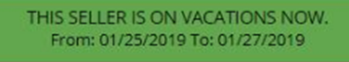

You don’t need the approval of Departax.

You can also block customers to make product reservations (disable the “add to cart” button for the products).

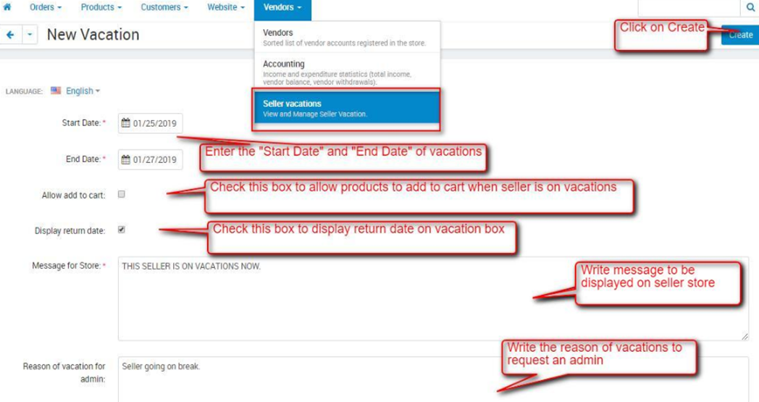

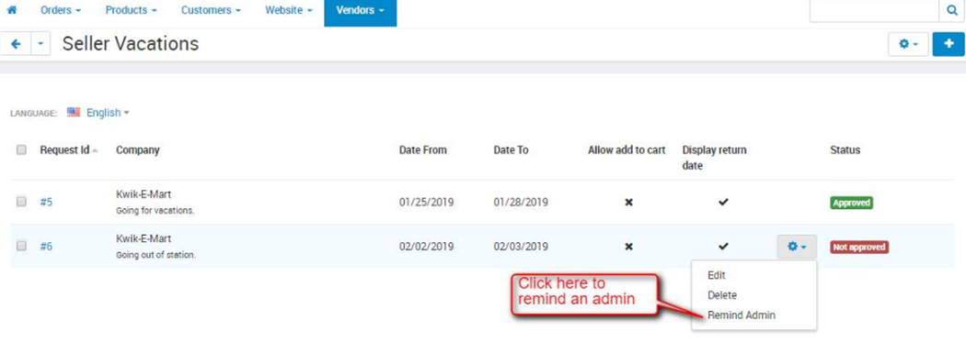

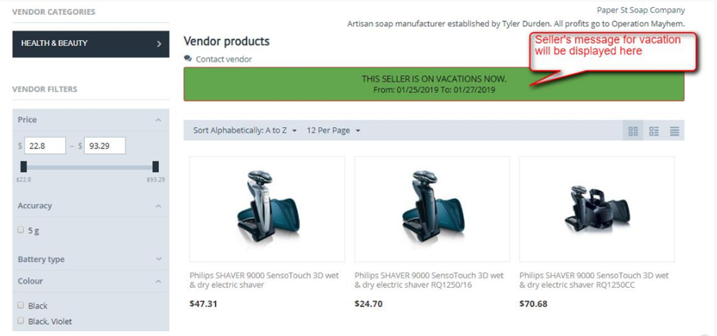

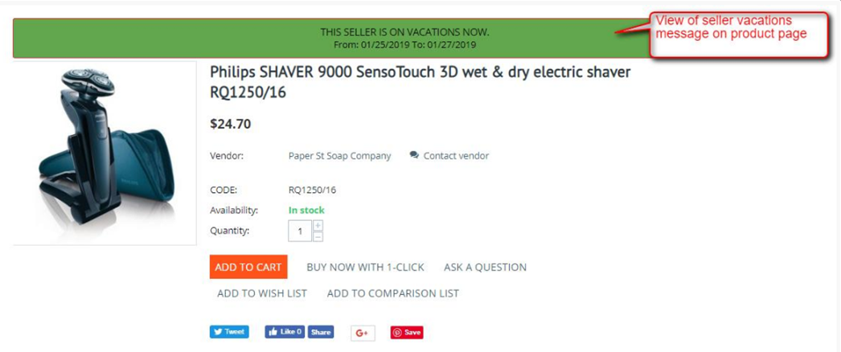

# 4.1 Orders

When you open the **Orders → View orders** section, the system automatically lists all orders from the database, i.e. the orders that have ever been placed and not deleted. By default, the list is arranged according to the date when the orders were placed, with the most recent orders at the top.

Click on the name of the corresponding column to sort orders by their IDs, statuses, and totals, as well as phone numbers, email addresses, or names of users who placed the orders.

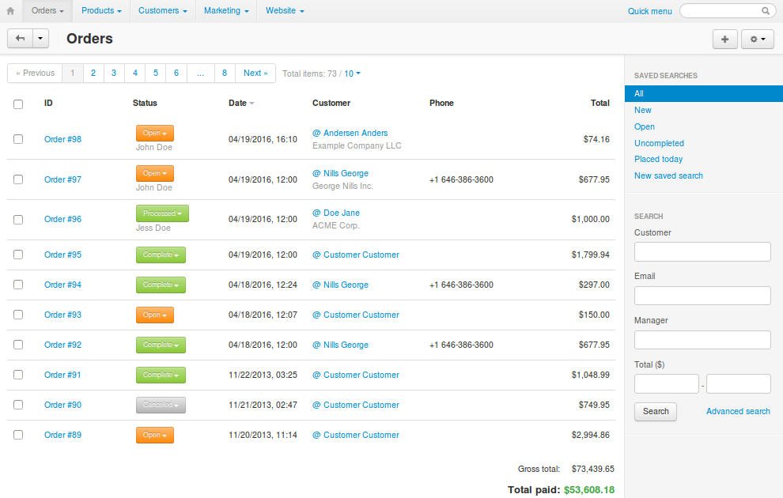

Use the search form on the right to display only those orders that meet certain criteria. By default, the form allows you to filter orders by:

* customer’s name.
* customer’s email address.
* the range of order totals.

Click Advanced search for more filtering criteria.

If you filter orders against a particular search pattern regularly (e.g., to list all new orders that were paid with a gift certificate), you can save the pattern. It will appear in the list of predefined patterns in the top right corner of the **View orders** page.

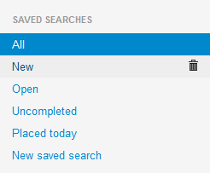

The **View orders** page allows you to:

* View all orders in the store, or just the orders that meet your search requirements.
* View incomplete orders by clicking the gear button and choosing **Incomplete orders**.

An order has the **Incomplete** status while it is being processed by a payment system. For example, an order has this status while a customer is entering credit card details on the payment system website and up until the customer is redirected back to your store.

* Change order statuses on the fly.
* View and edit order details.
* Add comments to an order; these comments may or may not be visible to the customer who placed the order.
* Export order details in the CSV format. The MYOB and Quickbooks add-ons allow you to export order details in other formats.
* Get orders from eBay (eBay synchronization add-on required).
* Print invoices and package slips both separately for each order or in bulk.
* Remove credit card info (if there is any).
* Create orders.
* Delete existing orders.
* Copy orders.

## How To Change Order Status

1. In the Administration panel of your store, go to **Orders → View orders**.
2. Find the desired order and click on its current status.
3. This will open the list of all available statuses. Click on the required status.

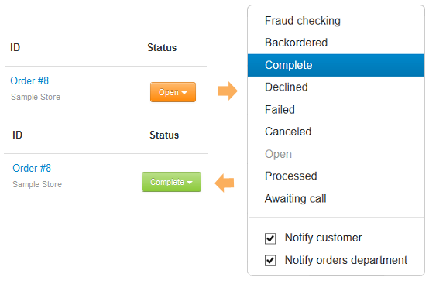

## How To View and Edit Order Details

## View Order Details

1. Go to **Orders → View orders** in the Administration panel of your store.
2. Click on the ID of the order you’d like to view.
3. The page with the order details will open. Here you can add comments to the order, create shipments, and assign a manager to the order.
4. If you make any changes on this page, click **Save changes**.

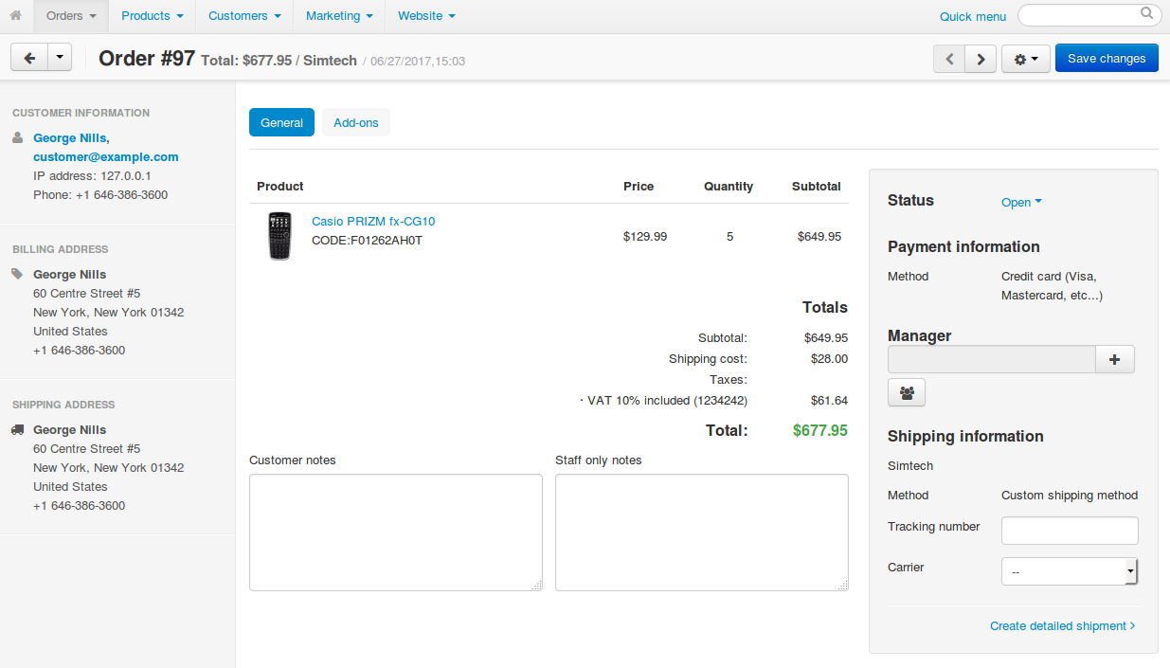

## Edit Order Details

When you edit an order, the promotions that apply to the order may be recalculated.

1. Click the **gear** button in the upper right part of the page.
2. Choose the **Edit order** action, and the order editing page will open.

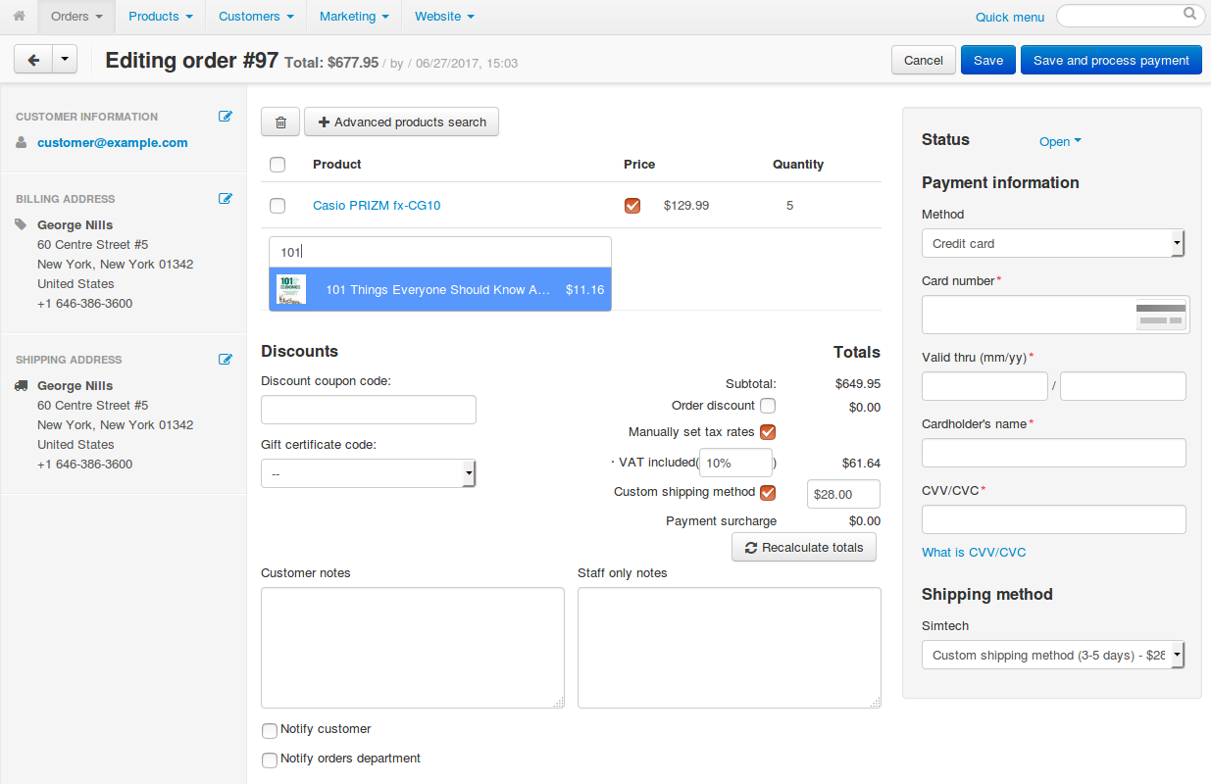

You can perform the following actions:

* + **Add a product to the order:** start entering the product’s name in the text field and choose one of the suggested products from the drop-down list. Alternatively, click **Advanced products search** and use the pop-up window to find and add the desired products.
  + **Remove a product from the order:** hover the mouse pointer over the product and click the **trash can** icon.
  + **Change the price of a product in the order:** tick the **Price** checkbox and edit the price. This will affect the price of the product only for this particular order, and not the price in the catalog.

If you want to edit the product in the catalog, click on the product’s name.

* + **Edit customer’s information and address:** click one of the **Edit** icons on the panel on the left, change the data in the pop-up window, then click **Update**.
  + **Choose payment method/shipping method/order status:** use the drop-down menus on the panel on the right.
  + **Apply a coupon code or gift certificate:** enter the coupon code or select the gift certificate under the list of products in the order.

1. Once you’ve made the changes, click **Save**.

# 4.2 Sales Reports

The **Orders → Sales reports** page contains detailed statistics on the sales that were made in your web store.

Statistics may be represented in a form of graphical or tabular charts. For convenience, charts are grouped into separate reports. You can use several existing reports or create your own.

To switch between reports, use the menu on the right.

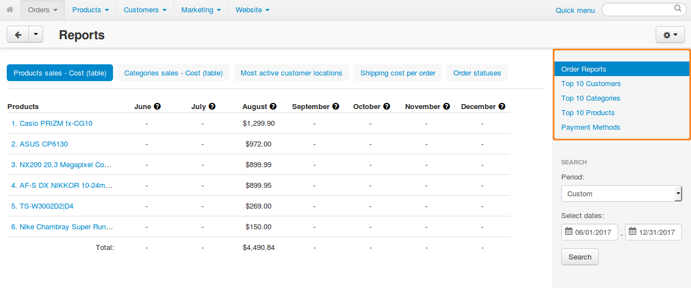

## How To Create a Sales Report

To create a custom report:

1. Go to **Orders → Sales reports.**
2. Click the gear button in the upper right part of the page.
3. Choose **Manage reports** to open the list of all available reports

.

1. Click the **+** button. The report creation form will open. Fill it in:
   * **Name**—the name of the report as it will appear in the list of reports.
   * **Status**—the status of the report: Active or Disabled.
2. Click the **Create** button. The new report will be listed among the other reports.

# 4.3 Shipments

For the moment, Shipments are not allowed. The customers must collect their articles at your store.

The software allows you to ship items from a single order in multiple batches and/or at different periods of time.

These batches are treated as separate **shipments** of one order. This is useful when you have to deal with backorders regularly.

For example, if a customer orders several items that are out of stock, you can ship the in-stock items right after the order has been placed, and can send the remaining items at a later date as a separate shipment.

## View Your Shipments

1. Go to **Orders → Shipments** to find the list of all the shipments created in your store.

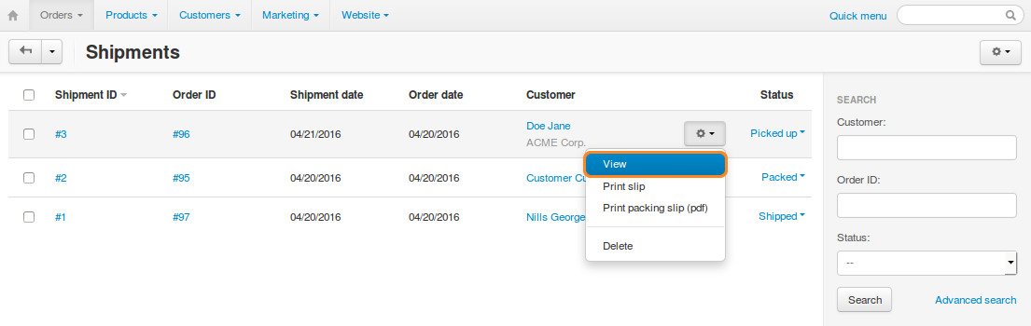

1. Click the ID of any shipment to see the details of the particular shipment. You can edit the comments and date. Remember to click **Save changes** once you’ve done that.

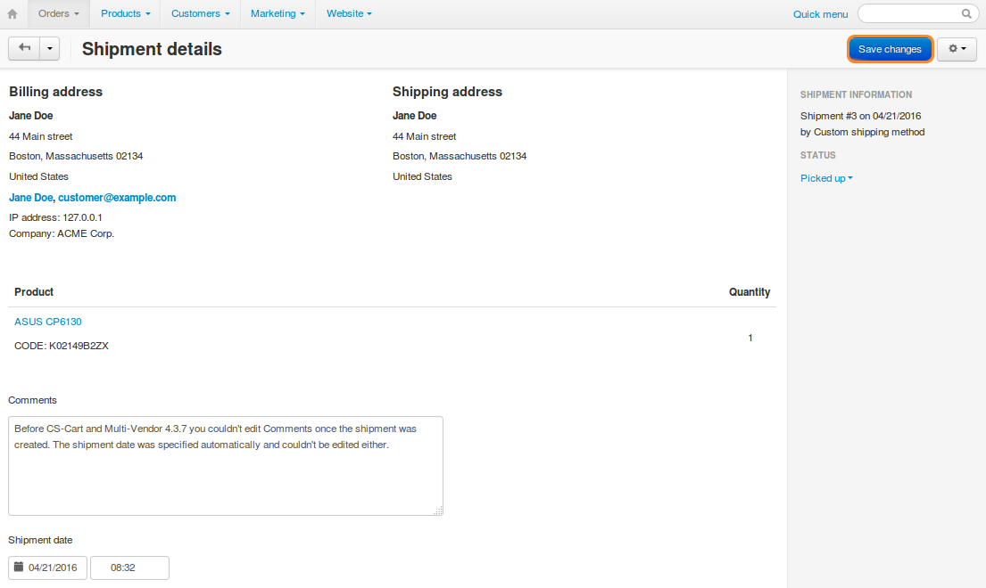

## How To Print Packing Slips

## Print a Packing Slip for One Shipment

To print a packing slip for a particular shipment, follow these steps:

1. Go to **Orders → Shipments**. You will see a list of all shipments in the store.
2. Find the shipment you need. If necessary, use the search panel to filter the list.
3. Click the gear button of the shipment for which you need to print a packing slip.
4. Choose **Print slip** from the drop-down list, if you want a package slip to be displayed in a separate browser tab for further printing. If you want to download the slip in the .pdf format, choose **Print packing slip (pdf)**.

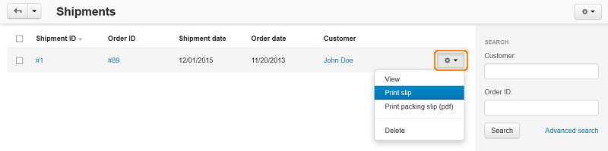

## Print Multiple Packing Slips at Once

To print several packing slips for multiple shipments at once, follow these steps:

1. Go to **Orders → Shipments**.
2. Tick the checkboxes of the shipments for which you need to print package slips.
3. Click the gear button in the upper right part of the page and choose **Packing slip bulk print**.
4. This will open a new page with the packing slips for all the selected shipments.

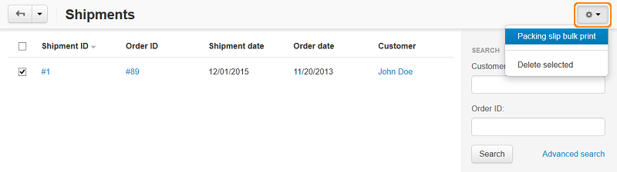

## How To Manage Shipment Statuses

If you go to **Orders → Shipments**, you will see all the list of all shipments in your store.

Shipments have statuses, allowing you to sort the list, or to search for shipments with a specific status.

By default, there are 3 statuses: Packed, Picked up, and Shipped. However, you can edit them, or add your own statuses.

Shipment statuses do not affect anything—they only help you manage your list of shipments.

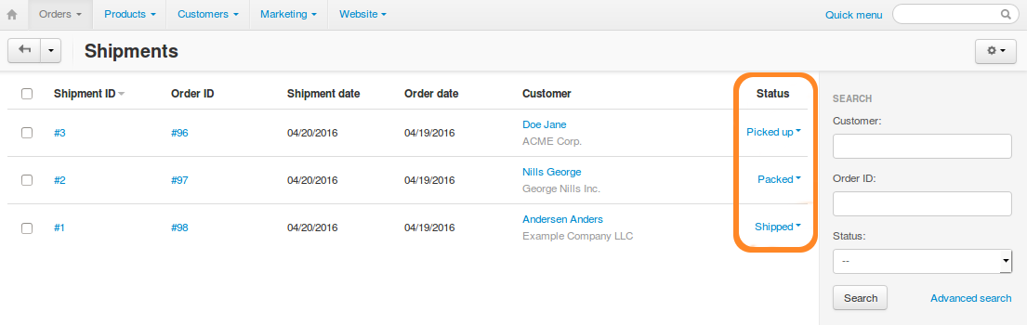

## Add Your Own Shipment Status

1. Go to **Administration → Shipping & taxes → Shipment statuses**.

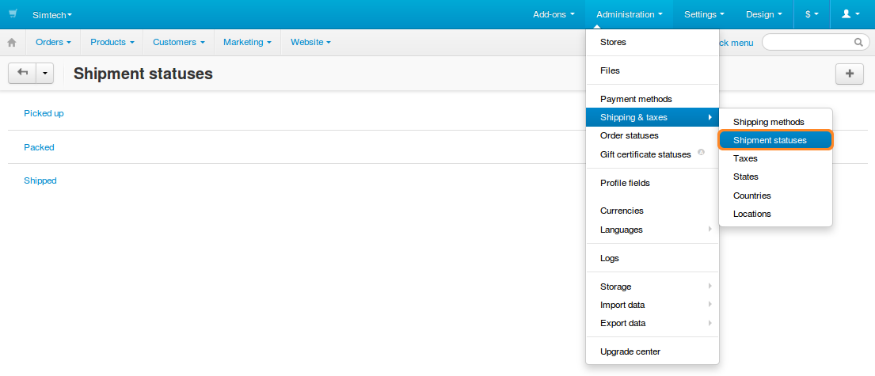

1. Click the **+** button in the top right corner, and choose **Add status**.
2. Name your status and click **Create**. After that you should be able to select your status on the shipment list.

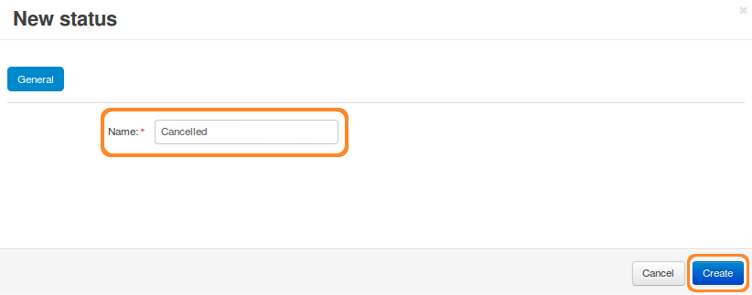

## Delete a Shipment Status

1. Go to **Administration → Shipping & taxes → Shipment statuses**.
2. Click the gear button of the shipment status.
3. Choose **Delete**.

You can also use the **Edit** action to change the name of the status.

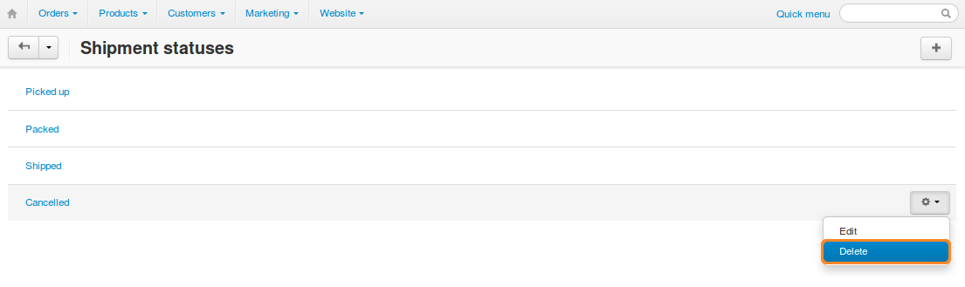

# 5.1 Blog

Customers will see the blogs under the Blog title on our Homepage.

To create your blog posts:

* Go to the **Website → Blog** section.
* Click the **+** button in the top right corner of the page.
* Fill in the fields of the given form:
  + Choose the parent page of a post. Leave it **Root level page** if you want this post to be displayed as the main page of a blog.
  + Complete the **Name** field. It will be a blog post header.
  + Write your blog, insert pictures or files in the **Post description** field.
  + Fill in other fields.
* Click **Create and close**. Your post will appear in the **Website → Blog** section.

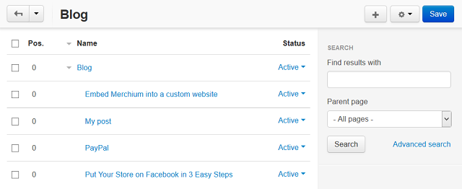

* Choose you newly created post by clicking on its name. You will see two additional tabs on the post editing page: **Comments** (if the **Comments and Reviews** add-on is enabled in your store) and **Layouts**.
* Manage settings in these tabs, if you wish.
* Save the changes.
* Create other posts of your blog in the same manner.

When your blog is ready to publish, send us a message so that we make your blog active.

This is an example of how your blog page will look like in the storefront:

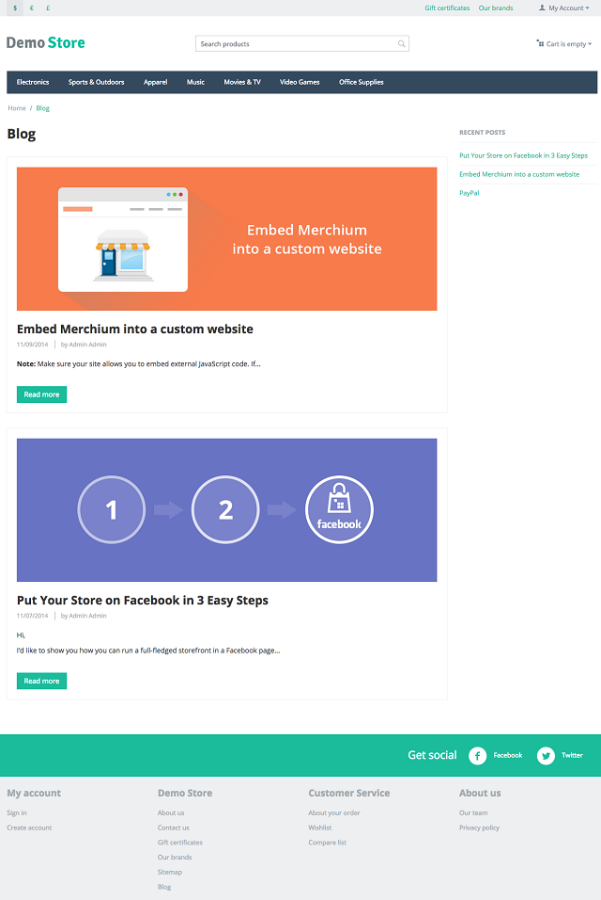

To customize all blog pages appearance, go to the **Design → Layouts** section and choose the **Blog** layout page.

## Blog Post Attributes

Blog posts that you can manage in the **Website → Blog** section have the following attributes:

## General

**Information**

* **Parent page** - Page that will contain a link to this post. If it is not intended that the page has a parent page, select the Root level option.
* **Name** - The header of the post.
* **Store** - Store to which the post originally belongs.
* **Post description** - Text of the blog post. It can be a plain text or a formatted HTML text. If you are not familiar with HTML, use the built-in WYSIWYG editor to create a formatted text.
* **Status** - Status of the post: Active or Disabled.

**Meta data**

* **Page title** - Title of the page, which is displayed in the title bar of the web browser. Required for SEO purposes.
* **META description** - Contents of the HTML meta tag describing the page. Required for SEO purposes.
* **META keywords** - Contents of the HTML tag containing a list of search keywords for the page. Required for SEO purposes.

**Availability**

* **User groups** - User groups whose members can access the page.
* **Creation date** - Date when the page was created.
* **Use available period** - If selected, the post is available for a certain period of time only.
* **Available from** - Date when the post becomes available for visitors.
* **Available till** - Date until the post is available for visitors.

## Add-ons

**Facebook**

* **Facebook object type** - Choose the object type on **Facebook** to characterize your page contents.

**SEO**

You must be logged in under the particular store administrator account to see this section

* **SEO name** - Search engine friendly name of the page containing the published post.

**Blog**

* **Image** - Upload an image to be shown as your blog post preview and at the beginning of the post.

**Comments and reviews**

You must be logged in under the particular store administrator account to see this section

* **Comments** - Select box to enable or disable user comments and ratings for the page.

## Tags

This tab includes a list of tags associated with the page. Tags appear on the storefront in a special side box titled **Tag cloud**..

* **Tags** – Tags that have been added to the post. Start typing in this field to add a new tag. You can choose among the existing variants or create a new tag.

## Comments

List of user comments and ratings for the post.

Requires that the **Comments** field in the **General** tab be set to *Communication*, *Rating*, or both:

* **Name** - Name of the user who left the comment/rating.
* **Your rating** - User’s evaluation of the post.
* **Your message** - Text of the comment.

## Layouts

This tab duplicates the global layout of the layout pages to which this storefront page belongs (**Design → Layouts**). By using this tab, you can disable blocks that are globally enabled, and, on the contrary, enable blocks that are globally disabled. This makes it possible to configure an individual layout for different storefront pages.

Any modification that you make under this tab will not affect other storefront pages.

## Share

Stores that share this post.

## How To Add the Recent Posts Section to the Storefront

To add the **Recent posts** section to the storefront:

Make sure that the **Blog** add-on is enabled in your store, and there are some blog posts created in the **Website → Blog** section.

* In the Administration panel of your store, go to **Design → Layouts** and choose a layout page, Homepage, for example.
* In the desired container click the **+** icon and choose **Add block**.
* In the opened window switch to the **Create New Block** tab and click the **Recent posts** button.
* Name a block, choose a template, and customize other settings.
* Click the **Create** button. A block with links to your latest blog posts is now added to the storefront.

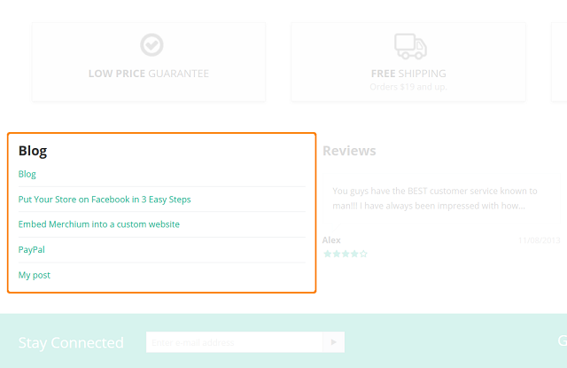

# 5.2 Pages

The **Website → Pages** section lets you create and publish new content of the following types:

* **Page**—a simple page that can only contain a text formatted in HTML. Good for various descriptions and policies.
* **Form** (requires the Form Builder add-on) a page that contains a contact form and optionally a text formatted in HTML. A user-friendly form builder doesn’t require any technical skills (such as HTML knowledge).
* **Poll** (requires the Polls add-on) a survey or a questionnaire.
* **Link**—a reference to an external web resource or any page of your web site. It serves two purposes:
  + It can appear among other content pages when you create a new block of the “Pages” type.
  + It lets you create links that seemingly belong to your site, but lead to your other resources, such as Facebook page.

So, instead of giving your customers a link to https://www.facebook.com/example.company/, you can give them a link like https://example.com/facebook that will lead to the same Facebook page.

To use a link in this manner, the [SEO](https://docs.cs-cart.com/latest/user_guide/addons/seo/index.html) add-on must be active. Otherwise, the link will look like this: http://example.com/?dispatch=pages.view&page_id=%pid%.

# 6.1 Shipping & Taxes

For now, Departax allows only product reservations, and no shipments.

The reservation fee is by default at 3 EUR.

It is not permitted to change this amount. Please contact us if you think this amount should change.

Sales Prices that you show on your products must be ALL TAXES INCLUDED.

# 6.2 Stores and Pickup Points

Show the addresses of your store and pickup points on the map to customers.

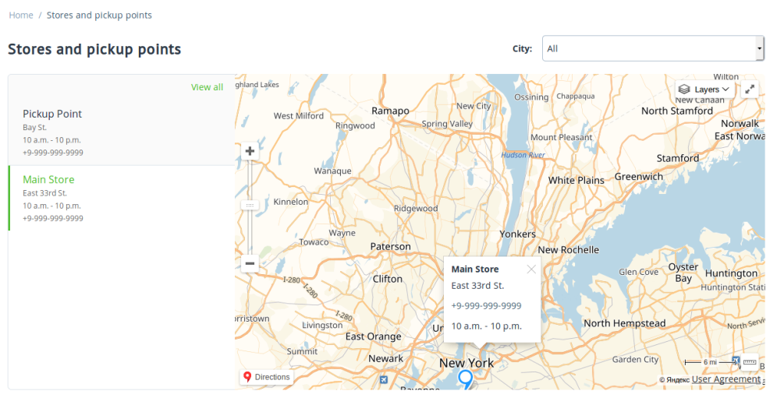

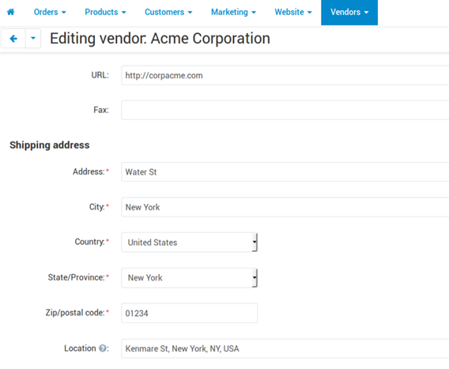

1. Go to General, edit your profile. It will be seen by customers clicking on MAP in the Menu.
2. Coordinates: click on Select, click on the position on the Google Map, click on Set and SAVE

# 6.3 Currencies

# 6.4 Logs

# 6.5 Files

# 6.6 Import Data

# 6.7 Export Data

# 7.1 Vendor’s administration

You can have 1 or more administrator for your online Show-Room.

You can add additional administrator by clicking the **+** button in the upper right part of the page, enter its email address, password.

# 7.2 Customers

You can see the list of your customers (with their name, email address, residence address).

# 7.3 Message Center

The system has 2 conversation tools.

You can send messages with this tool but not attach files (like pictures, photos).

Please use the other tool (in 2.1 Messages-**→ C**onversation) to send/receive files.

# 8.1 Themes

You can change the colours/fronts/background of your store.

# 8.2 Layout

# Need help? eBay, Amazon, Etsy synchronisation? Missing Categories/Subcategories?

Contact us ([retailer@departax.com](mailto:retailer@departax.com))

------------------------------------

# List of Categories/Subcategories

**Contact us if you don’t find your City in the Subcategories (retailer@departax.com).**

**Africa**

Algeria

Angola

Benin

Botswana

Burkina Faso

Burundi

Cape Verde

Central African Republic

Chad

Comoros

Congo (Brazzaville)

Congo (Kinshasa)

Djibouti

Egypt

Equatorial Guinea

Eritrea

Ethiopia

Gabon

Gambia

Ghana

Guinea

Guinea-Bissau

Ivory Coast

Kenya

Lesotho

Liberia

Libya

Madagascar

Malawi

Mali

Mauritania

Mauritius

Morocco

Mozambique

Namibia

Niger

Nigeria

Rwanda

Sao Tome

Senegal

Seychelles

Sierra Leone

Somalia

South Africa

South Sudan

Sudan

Swaziland

Tanzania

Togo

Tunisia

Uganda

Zambia

Zimbabwe

**Asia**

Afghanistan

Armenia

Azerbaijan

Bangladesh

Bhutan

Brunei

Cambodia

China

East Timor

Georgia

Hong-Kong

India

Indonesia

Japan

Kazakhstan

Kyrgyztan

Laos

Malaysia

Maldives

Mongolia

Myanmar

Nepal

North Korea

Pakistan

Philippines

Singapore

South Korea

Sri Lanka

Taiwan

Tajikistan

Thailand

Turkmenistan

Uzbekistan

Vietnam

**Caribbean Islands**

Anguilla

Antigua and Barbuda

Aruba

Bahamas

Barbados

Bonaire

British Virgin Islands

Cayman Islands

Cuba

Curaçao

Dominican Republic

Grenada

Guadeloupe

Haiti

Jamaica

Martinique

Puerto Rico

Saint Kitts and Nevis

Saint Lucia

Saint Martin

Saint Vincent and the Grenadines

Sint Maarten

Trinidad and Tobago

Turks and Caicos Islands

United States Virgin Islands

**Europe**

Albania

Andorra

Austria

Belarus

Belgium

Bosnia and Herzegovina

Bulgaria

Croatia

Cyprus

Czech Republic

Denmark

Estonia

Finland

France

Germany

Greece

Hungary

Iceland

Ireland

Italy

Kosovo

Latvia

Liechtenstein

Lithuania

Luxembourg

Malta

Moldova

Monaco

Montenegro

Netherlands

North Macedonia

Norway

Poland

Romania

Russia

Serbia

Slovakia

Slovenia

Spain

Sweden

Switzerland

Turkey

Ukraine

United Kingdom

**Middle-East**

Abu Dhabi

Bahrain

Dubai

Iran

Iraq

Israel

Jordan

Kuwait

Lebanon

Oman

Palestine

Qatar

Saudi Arabia

Sharjah

Syria

Yemen

**North America**

Bermuda

Canada

Costa Rica

El Salvador

Guatemala

Honduras

Mexico

Nicaragua

Panama

USA

**Oceania/Australia**

Alotau

Apia

Australia

Bora Bora

Fakarava

Hilo

Honolulu

Kahului

Lautoka

Maré Island

Moorea

Nawiliwili

New Zealand

Noumea

Nuku Hiva

Pago Pago

Pago Pago

Papeete (Tahiti)

Port Moresby

Raiatea

Rangiroa

Samoa

Suva

Vanuatu

**South America**

Argentina

Bolivia

Brazil

Chile

Colombia

Ecuador

French Guiana

Guyana

Paraguay

Peru

Suriname

Uruguay

Venezuela

**Electronics**

Computers

Tablets

Hard Disk

Data Storage

Digital Media Player

eBook Readers

Flashes

Headphones

CD-DVD Players

Speakers

Sports & Handheld GPS

Smartphones

Calculators

Home Audio Accessories

Home Theater

Monitors

Printers & Scanners

Projectors

Security & Surveillance

Servers

Televisions

Video Games

Video Recorders

Video Surveillance

Aviation Electronics

Car Electronics

Marine Electronics

Vehicle Electronics

Drones

Binoculars & Scopes

Cameras

Film Photography

Lenses

Lighting & Studio

Tripods & Monopods

Underwater Photography

**Jewellery**

Anklets

Bracelets

Brooches & Pins

Earrings

Jewelry Sets

Necklaces

Rings

Wedding & Engagement

Smart Jewelry

Body Jewelry

**Watches**

Wrist Watches

Smartwatches

Watch Bands

Pocket Watches

Antique Watches

**Handmade & Collector**

Coins - Stamps

Dress

Fabrics

Gifts

Jewelry Making

Metal & Wood Working

Paintings - Drawings - Printings

Photography

Rugs

Sculptures

Vintage

Other Arts & Crafts

**Fashion (Women)**

Clothing 6

Shoes

Accessories

**Fashion (Men)**

Clothing

Shoes

Accessories

**Baby & Children**

Apparel & Accessories

Baby Care

Car Seats & Travel

Gifts (Baby)

Pregnancy & Maternity

Strollers & Accessories

Accessories

Clothing

Gifts (Children)

Shoes

**Music & Movies**

CD

DVD

Vinyl

Music Instruments

**Books**

Antique Books

Antique Magazines

Children Books

Comics

Other Books

**Perfume - Beauty - Personal Care**

Bags & Cases

Bathing Accessories

Deodorants & Antiperspirants

Hair Care

Foot, Hand & Nail Care

Perfume

Makeup

Personal Care

Oral Care

Mirrors

Skin Care

Shave & Hair

Salon & Spa Equipment

**Sports & Outdoor**

Other Sports

Camping & Hiking

Climbing

Cycling

Bags, Packs & Accessories

Caps & Hats

Boating & Sailing

Electronics

Footwear

Golf

Jewelry & Watches

Exercise & Fitness

Hunting & Fishing

Sport Clothing

Running

Sport Accessories

Skates, Skateboards & Scooters

Sports Equipment

Sports Medicine

Swimming

Team Sports

Tennis & Racquet Sports

Sports Souvenirs

Yoga

Water Sports

Winter Sports

**Travel**

Carry-ons

Backpacks

Garment bags

Travel Totes

Luggage Sets

Laptop Bags

Suitcases

Kids Luggage

Bags

Duffles

Travel Accessories & Umbrellas

Drinkware

**Home & Kitchen**

Bedroom

Bathroom

Furniture

Drawings

Event & Party Supplies

Cleaning

Kids

Home Décor

Lights

Heating & Cooling

Irons & Steamers

Small Appliances

Storage

Paintings

Photographs

Posters & Prints

Water Coolers & Filters

Wine Accessories

Vacuums

**Toys & Games**

Action Figures & Statues

Arts & Crafts

Baby & Toddler Toys

Building Toys

Dolls & Accessories

Dress

Electronics Games

Games

Grown-Up Toys

Hobbies

Kids' Furniture, Décor & Storage

Learning & Education

Novelty & Gag Toys

Party Supplies

Puppets

Puzzles

Stuffed Animals & Plush Toys

Tricycles, Scooters & Wagons

Vehicles

Video Games

**Food & Drinks**

Alcohol

Food

Wine

**Influencers (new category)**