User Manual (Show-Room)

(version 18-12-2019)

# How to create your online Show-Room in 10 minutes (without the Reservation option)

**Departax.com is a show-room and reservation platform. Clients can use departax.com to reserve a product (not buy) before travelling, to be sure to get it. When arrived, they will pay and collect the reserved product directly at your store.**

There are many options in our software but you may not need all of them.

**Here is our guide to open your online Show-Room in just 10 minutes, using just the most important options.**

Always select the ENGLISH language and the EUR currency when you work on your Show-Room.

Our website is for the time being active only in English and in EUR.

**1st step: Open your Show-Room**

REGISTER on departax.com (under My Account)

* Enter your email address and a new password

Click on “Open you Show-Room”

For the plan, click on CHOOSE

* Enter your Store name and the (Country). **Ex: ACMO (Belgium)**
* Enter a description of your activity (this will appear on your store page and on the menu ‘List of Retailers’)
* Enter your first and last name. **Ex: Robert Quest**
* Enter your email address, phone and address (all these in English)
* Click on SUBMIT

When we confirm your registration, you will receive an email and can then start creating your online Show-Room.

**2nd step: Add your products**

Go to [www.departax.com/vendor.php](http://www.departax.com/vendor.php)

Enter your email address and password

Go to Products -> Products

Click on + Add Product:

* Enter the name of the product and (the price and the local currency if it is not Euros). Ex: Chanel No.5 (USD 55)
* Categories: select the **subcategory** from our list, see the list of subcategories at the end of this User Guide, and add also, as a second subcategory, the City name of your store (in English!). This will help customers find your store in the right categories on the Menu. **Ex: Perfume; Brussels**

Contact us if you need a new subcategory/category or a new City name

* Price: set the **EUR price** of your product to **zero**
* Images: click on SELECT images to upload the images of your product
* In Stock: set the stock to **zero**. This will allow customers to order your products
* Zero price action: select “**Do not allow customers to add the product to cart**”
* Search: enter the name and the key search words of your product. **Ex: Chanel No.5 perfume**

Click on CREATE, click on the box ‘**Add-ons**’, go to **Preorder**:

* Enable PreOrder: select “**NO**”

**3rd step: Show your store on the Map**

**This will help your customers easily find your store on our Google Map, before or after travelling to your country.**

Go to Administration -> Stores and pickup points

Click on + Add Store Location

* Enter the name of your store and the (location). **Ex: ACMO (City Centre)**
* Enter the priority/position of your store, if you have multiple stores: **1, 2 etc**
* Enter the address of the store
* Enter the phone number of your store
* Enter the working hours, opening days (in English!). **Ex: Monday to Friday: 9am to 6pm. Saturday-Sunday: closed**
* Select the Country of your store
* Enter the City (in English!)
* Click on SELECT to find the position of your store on Google Map, and **click on the exact position and then on SET**
* Click on CREATE and then on SAVE

**How to Clone a product**

**This will save you some time when adding products**

Go to Products -> Products

Select the product you want to copy

Click on Actions, CLONE, and SAVE

Click on the new product and make the necessary corrections (Product name, Image, In Stock, Search words, etc)

Check if all the data is correct. You may need to go again to Add-on and correct the data there

**Show your logo**

Go to Retailers -> Retailers -> Logos

Click on Local and upload your logo on departax.com and also on invoices

**Terms & Conditions**

Enter your Terms and Conditions

**Show that your store is closed**

**This will inform your customers that your store is closed**

**Last step: Check again in all our website if your data is correct**

Go on departax.com -> List of Retailers

Go to Retailers by Category -> YOUR DESTINATION

Go to the category of your product

Go to Map

**Are you offering a VAT refund to tourists?**

Contact us to show the VAT Refund badge. This will attract more tourists

**Need help?**

Send us an email ([retailer@departax.com](mailto:retailer@departax.com))

---------------------------------------

# How to create your online Show-Room in 10 minutes (with the Reservation option)

Go to Products -> Products

* Price: enter the **EUR price** of your product. This is the price including all the local taxes

Click on the box ‘**Add-ons**’, go to **Preorder**:

* Enable PreOrder: select “**YES**”
* PreOrder Type: select “**Partial Price**”
* PreOrder Ending Date: select the date **31/12/2029**
* Maximum PreOrder Quantity: select “**1**”
* Per User Product: select “**1**”
* PreOrder Product Price: enter the % amount of your sale price **in order to reach a PreOrder price of EUR 3**

For example, your sale price is EUR 30, then you must enter 10% in this field, in order to reach a PreOrder price of EUR 3. The PreOrder price (EUR 3) is the price the Client will pay to us in order to reserve your product.

* Reviews: select “Communication and Rating” to allow your customer to leave a review or a rating on your product

---------------------------------------

# Conversations

You can exchange messages (and send files like pictures) with customers.

It can be very useful if the customer wants to ask questions about your products, prices, reservations and delivery.

You can write a message under Message, you can attach files (picture, photo, etc), and click on SEND.

# 

The customer starts a conversation by clicking on the **Contact Vendor** button.

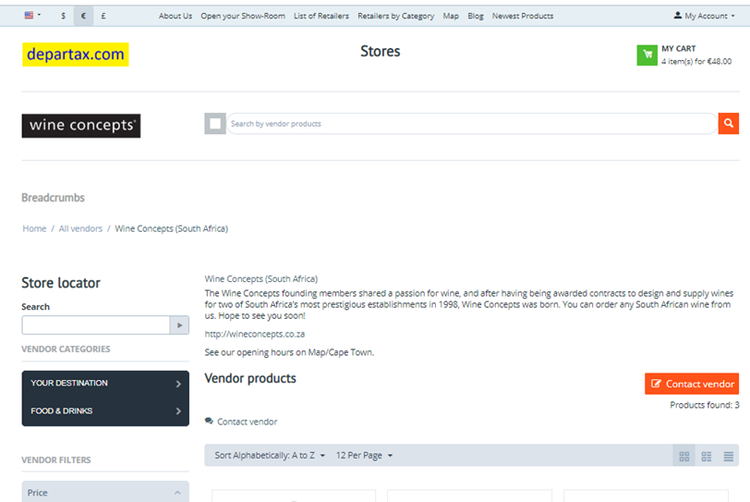

# 

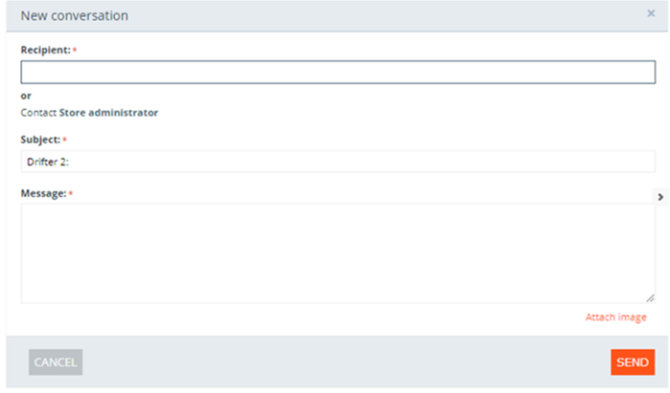

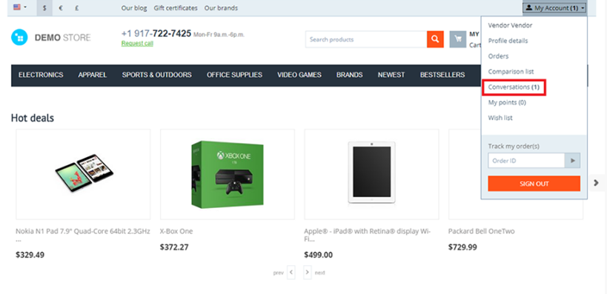

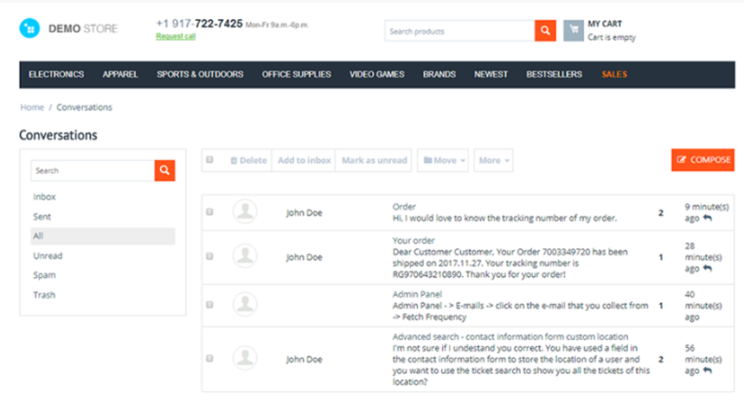

---------------------------------------

# Seller Vacations

With this tool, you can inform customers that your store will be closed.

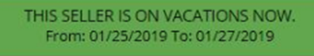

You don’t need the approval of Departax.

You can also block customers to make product reservations (disable the “add to cart” button for the products).

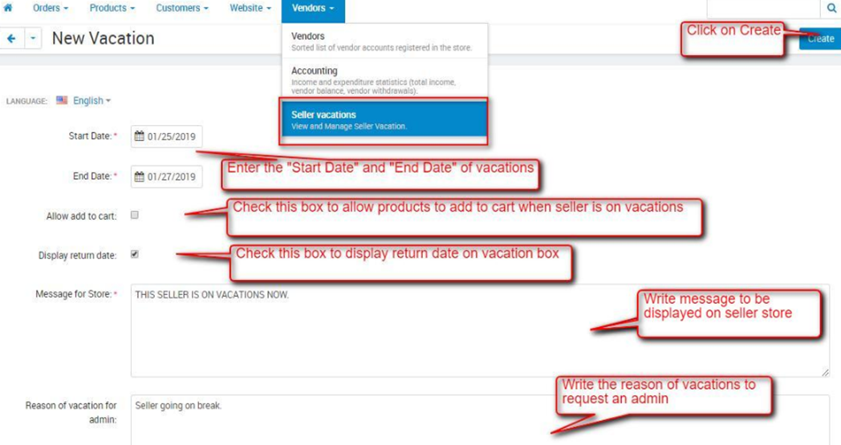

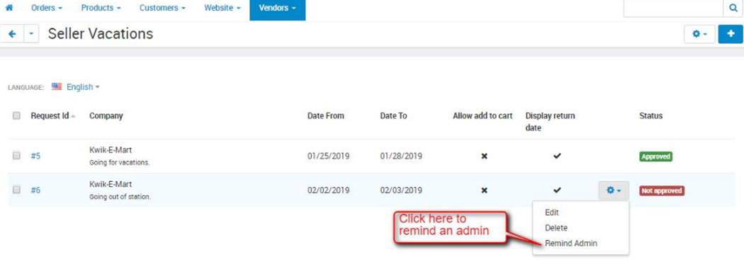

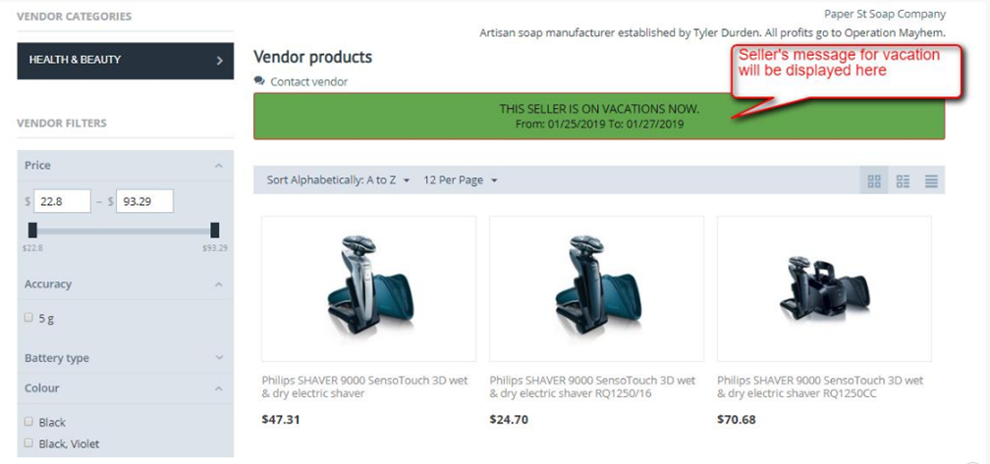

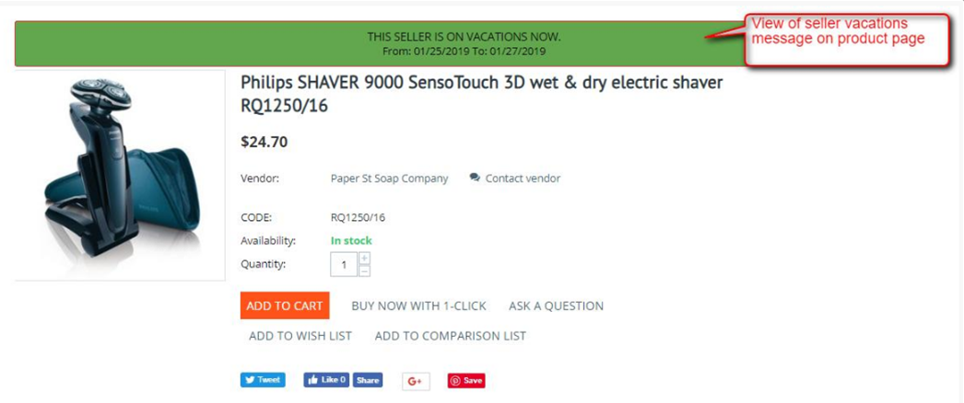

---------------------------------------

# Stores and Pickup Points

Show the addresses of your store and pickup points on the map to customers.

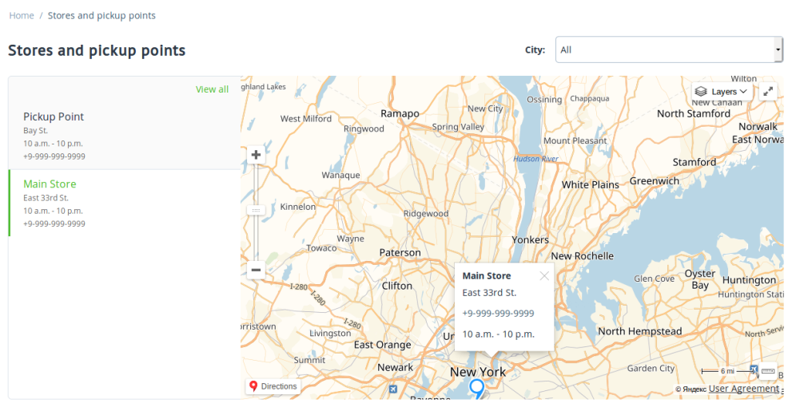

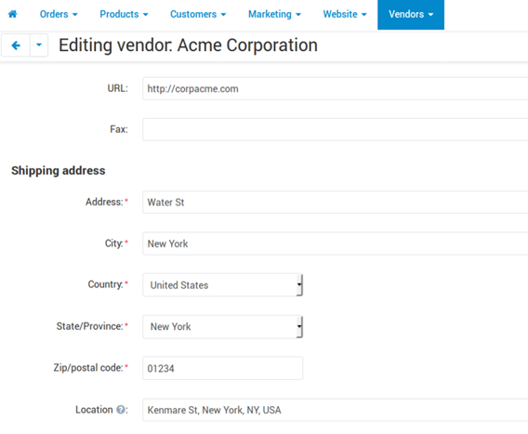

1. Go to General, edit your profile. It will be seen by customers clicking on MAP in the Menu.
2. Coordinates: click on Select, click on the position on the Google Map, click on Set and SAVE

---------------------------------------

# Message Center

The system has 2 conversation tools.

You can send messages with this tool but not attach files (like pictures, photos).

Please use the other tool (**C**onversation) to send/receive files.

---------------------------------------

# Need help? Missing Categories/Subcategories?

Contact us ([retailer@departax.com](mailto:retailer@departax.com))

---------------------------------------

# List of Categories/Subcategories

**Contact us if you don’t find your City in the Subcategories (retailer@departax.com).**

**Africa**

Algeria

Angola

Benin

Botswana

Burkina Faso

Burundi

Cape Verde

Central African Republic

Chad

Comoros

Congo (Brazzaville)

Congo (Kinshasa)

Djibouti

Egypt

Equatorial Guinea

Eritrea

Ethiopia

Gabon

Gambia

Ghana

Guinea

Guinea-Bissau

Ivory Coast

Kenya

Lesotho

Liberia

Libya

Madagascar

Malawi

Mali

Mauritania

Mauritius

Morocco

Mozambique

Namibia

Niger

Nigeria

Rwanda

Sao Tome

Senegal

Seychelles

Sierra Leone

Somalia

South Africa

South Sudan

Sudan

Swaziland

Tanzania

Togo

Tunisia

Uganda

Zambia

Zimbabwe

**Asia**

Afghanistan

Armenia

Azerbaijan

Bangladesh

Bhutan

Brunei

Cambodia

China

East Timor

Georgia

Hong-Kong

India

Indonesia

Japan

Kazakhstan

Kyrgyztan

Laos

Malaysia

Maldives

Mongolia

Myanmar

Nepal

North Korea

Pakistan

Philippines

Singapore

South Korea

Sri Lanka

Taiwan

Tajikistan

Thailand

Turkmenistan

Uzbekistan

Vietnam

**Caribbean Islands**

Anguilla

Antigua and Barbuda

Aruba

Bahamas

Barbados

Bonaire

British Virgin Islands

Cayman Islands

Cuba

Curaçao

Dominican Republic

Grenada

Guadeloupe

Haiti

Jamaica

Martinique

Puerto Rico

Saint Kitts and Nevis

Saint Lucia

Saint Martin

Saint Vincent and the Grenadines

Sint Maarten

Trinidad and Tobago

Turks and Caicos Islands

United States Virgin Islands

**Europe**

Albania

Andorra

Austria

Belarus

Belgium

Bosnia and Herzegovina

Bulgaria

Croatia

Cyprus

Czech Republic

Denmark

Estonia

Finland

France

Germany

Greece

Hungary

Iceland

Ireland

Italy

Kosovo

Latvia

Liechtenstein

Lithuania

Luxembourg

Malta

Moldova

Monaco

Montenegro

Netherlands

North Macedonia

Norway

Poland

Romania

Russia

Serbia

Slovakia

Slovenia

Spain

Sweden

Switzerland

Turkey

Ukraine

United Kingdom

**Middle-East**

Abu Dhabi

Bahrain

Dubai

Iran

Iraq

Israel

Jordan

Kuwait

Lebanon

Oman

Palestine

Qatar

Saudi Arabia

Sharjah

Syria

Yemen

**North America**

Bermuda

Canada

Costa Rica

El Salvador

Guatemala

Honduras

Mexico

Nicaragua

Panama

USA

**Oceania/Australia**

Alotau

Apia

Australia

Bora Bora

Fakarava

Hilo

Honolulu

Kahului

Lautoka

Maré Island

Moorea

Nawiliwili

New Zealand

Noumea

Nuku Hiva

Pago Pago

Pago Pago

Papeete (Tahiti)

Port Moresby

Raiatea

Rangiroa

Samoa

Suva

Vanuatu

**South America**

Argentina

Bolivia

Brazil

Chile

Colombia

Ecuador

French Guiana

Guyana

Paraguay

Peru

Suriname

Uruguay

Venezuela

**Electronics**

Computers

Tablets

Hard Disk

Data Storage

Digital Media Player

eBook Readers

Flashes

Headphones

CD-DVD Players

Speakers

Sports & Handheld GPS

Smartphones

Calculators

Home Audio Accessories

Home Theater

Monitors

Printers & Scanners

Projectors

Security & Surveillance

Servers

Televisions

Video Games

Video Recorders

Video Surveillance

Aviation Electronics

Car Electronics

Marine Electronics

Vehicle Electronics

Drones

Binoculars & Scopes

Cameras

Film Photography

Lenses

Lighting & Studio

Tripods & Monopods

Underwater Photography

**Jewellery**

Anklets

Bracelets

Brooches & Pins

Earrings

Jewelry Sets

Necklaces

Rings

Wedding & Engagement

Smart Jewelry

Body Jewelry

**Watches**

Wrist Watches

Smartwatches

Watch Bands

Pocket Watches

Antique Watches

**Handmade & Collector**

Coins - Stamps

Dress

Fabrics

Gifts

Jewelry Making

Metal & Wood Working

Paintings - Drawings - Printings

Photography

Rugs

Sculptures

Vintage

Other Arts & Crafts

**Fashion (Women)**

Clothing 6

Shoes

Accessories

**Fashion (Men)**

Clothing

Shoes

Accessories

**Baby & Children**

Apparel & Accessories

Baby Care

Car Seats & Travel

Gifts (Baby)

Pregnancy & Maternity

Strollers & Accessories

Accessories

Clothing

Gifts (Children)

Shoes

**Music & Movies**

CD

DVD

Vinyl

Music Instruments

**Books**

Antique Books

Antique Magazines

Children Books

Comics

Other Books

**Perfume - Beauty - Personal Care**

Bags & Cases

Bathing Accessories

Deodorants & Antiperspirants

Hair Care

Foot, Hand & Nail Care

Perfume

Makeup

Personal Care

Oral Care

Mirrors

Skin Care

Shave & Hair

Salon & Spa Equipment

**Sports & Outdoor**

Other Sports

Camping & Hiking

Climbing

Cycling

Bags, Packs & Accessories

Caps & Hats

Boating & Sailing

Electronics

Footwear

Golf

Jewelry & Watches

Exercise & Fitness

Hunting & Fishing

Sport Clothing

Running

Sport Accessories

Skates, Skateboards & Scooters

Sports Equipment

Sports Medicine

Swimming

Team Sports

Tennis & Racquet Sports

Sports Souvenirs

Yoga

Water Sports

Winter Sports

**Travel**

Carry-ons

Backpacks

Garment bags

Travel Totes

Luggage Sets

Laptop Bags

Suitcases

Kids Luggage

Bags

Duffles

Travel Accessories & Umbrellas

Drinkware

**Home & Kitchen**

Bedroom

Bathroom

Furniture

Drawings

Event & Party Supplies

Cleaning

Kids

Home Décor

Lights

Heating & Cooling

Irons & Steamers

Small Appliances

Storage

Paintings

Photographs

Posters & Prints

Water Coolers & Filters

Wine Accessories

Vacuums

**Toys & Games**

Action Figures & Statues

Arts & Crafts

Baby & Toddler Toys

Building Toys

Dolls & Accessories

Dress

Electronics Games

Games

Grown-Up Toys

Hobbies

Kids' Furniture, Décor & Storage

Learning & Education

Novelty & Gag Toys

Party Supplies

Puppets

Puzzles

Stuffed Animals & Plush Toys

Tricycles, Scooters & Wagons

Vehicles

Video Games

**Food & Drinks**

Alcohol

Food

Wine

**Influencers (new category)**